Answers to questions in

Lab 1: Filtering operations

Name: ___Simon_Lagerqvist________________________ Program: ___TIEDB__________________

**Instructions**: Complete the lab according to the instructions in the notes and respond to the questions stated below. Keep the answers short and focus on what is essential. Illustrate with figures only when explicitly requested.

Good luck!

___________________________________________________________________________

**Question 1**: Repeat this exercise with the coordinates p and q set to (5, 9), (9, 5), (17, 9),

(17, 121), (5, 1) and (125, 1) respectively. What do you observe?

Answers:

The correlation between the frequency domain and the spatial domain in 2 dimensions. Adding one frequency will add that frequency in the spatial plane.

___________________________________________________________________________

**Question 2**: Explain how a position (p, q) in the Fourier domain will be projected as a sine wave in the spatial domain. Illustrate with a MATLAB figure.

Answers:

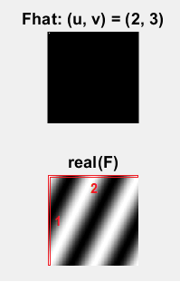Since the Fourier domain is the frequency domain, it represents the frequency content of the “original” image in the spatial domain in two dimensions (p, q). If we enter a certain frequency in the Fourier domain in one direction, it will result in that frequency showing up in the spatial domain.

We can observe in the image that that we have a 1 hertz change in the y direction and a 2 hertz change in the x direction. Note that for u = 2 will correspond to 1 hertz since MATLAB matrixes are indexed from 1 instead of 0. The 0 frequency is at the end/corner.

The frequency in the frequency domain is decided by the coordinates and will dictate the frequency on the sine in the spatial domain. If the frequency in added in p, q will correspond to the change in the x, y directions in the spatial domain, and will dictate the rotation of the sine wave pattern relative to x, y axis

___________________________________________________________________________

**Question 3**: How large is the amplitude? Write down the expression derived from Equation (4) in the notes. Complement the code (variable amplitude) accordingly.

Answers:

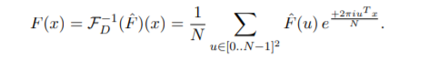

We only have one pixel which represents only one frequency. Since the value of that pixel is one, it means that the amplitude for that pixel will be 1/N. If we take abs of we will get a |a*e^-iwx|.

___________________________________________________________________________

**Question 4**: How does the direction and length of the sine wave depend on p and q? Write down the explicit expression that can be found in the lecture notes. Complement the code (variable wavelength) accordingly.

Answers:

We use the frequencies in both directions (axis) and use Pythagoras to get the wavelength in the correct angle.

The direction depends on the relationship between the frequencies in the two directions.

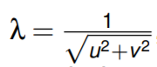

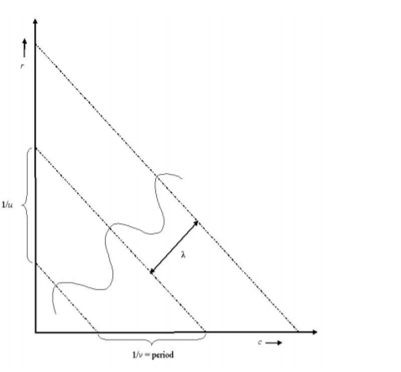

_____________________________________________________________________________

**Question 5**: What happens when we pass the point in the center and either p or q exceeds half the image size? Explain and illustrate graphically with Matlab!

Answers:

We enter the negative frequency domain for either one or both the two axes. The frequencies become mirrored.

___________________________________________________________________________

**Question 6**: What is the purpose of the instructions following the question *What is done by these instructions?* in the code?

Answers:

The coordinates/frequency for mirrored f-hat are calculated. If the coordinates overreach the center of the plane, they get mirrored by applying -1/2 of the total length and height. This is needed for the coordinates to correspond to the correct frequency.

___________________________________________________________________________

**Question 7**: Why are these Fourier spectra concentrated to the borders of the images? Can you give a mathematical interpretation? Hint: think of the frequencies in the source image and consider the resulting image as a Fourier transform applied to a 2D function. It might be easier to analyze each dimension separately!

Answers:

The vertical part of the fourier transform can be replaced with a discrete dirac function since there is no change in the image in the horizontal plane and all the parts distributed around the “unit”- circle will be have the same amplitude and cancel each other when summed up, the only part that will be left is the real at the v=0 column. This behavior is the same as the descrete dirac function.

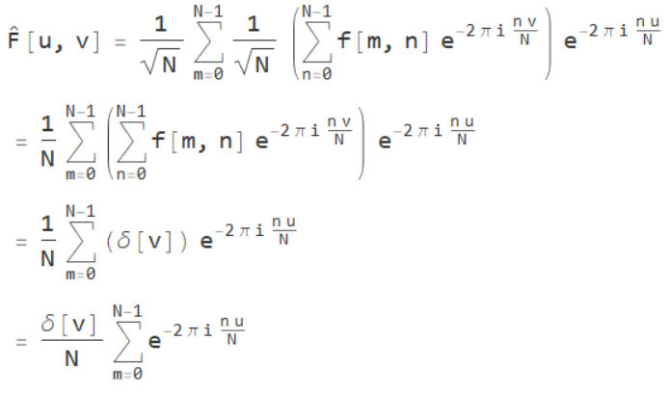

In the direction we have a change, we will get a square wave, which can be represented as a sum of sin waves, which we can observe in the Fourier domain

__________________________________________________________________________

**Question 8**: Why is the logarithm function applied?

Answers:

Logarithmic compression makes it easier to see images with a large dynamic range by enhancing the darker parts and making them cover a larger section of the given screens dynamic range. We need the parameter alpha since the logarithm isn’t defined (or negative) for values less than one. Making alpha larger makes the image lighter since lowest value is moved up in the contrast scale.

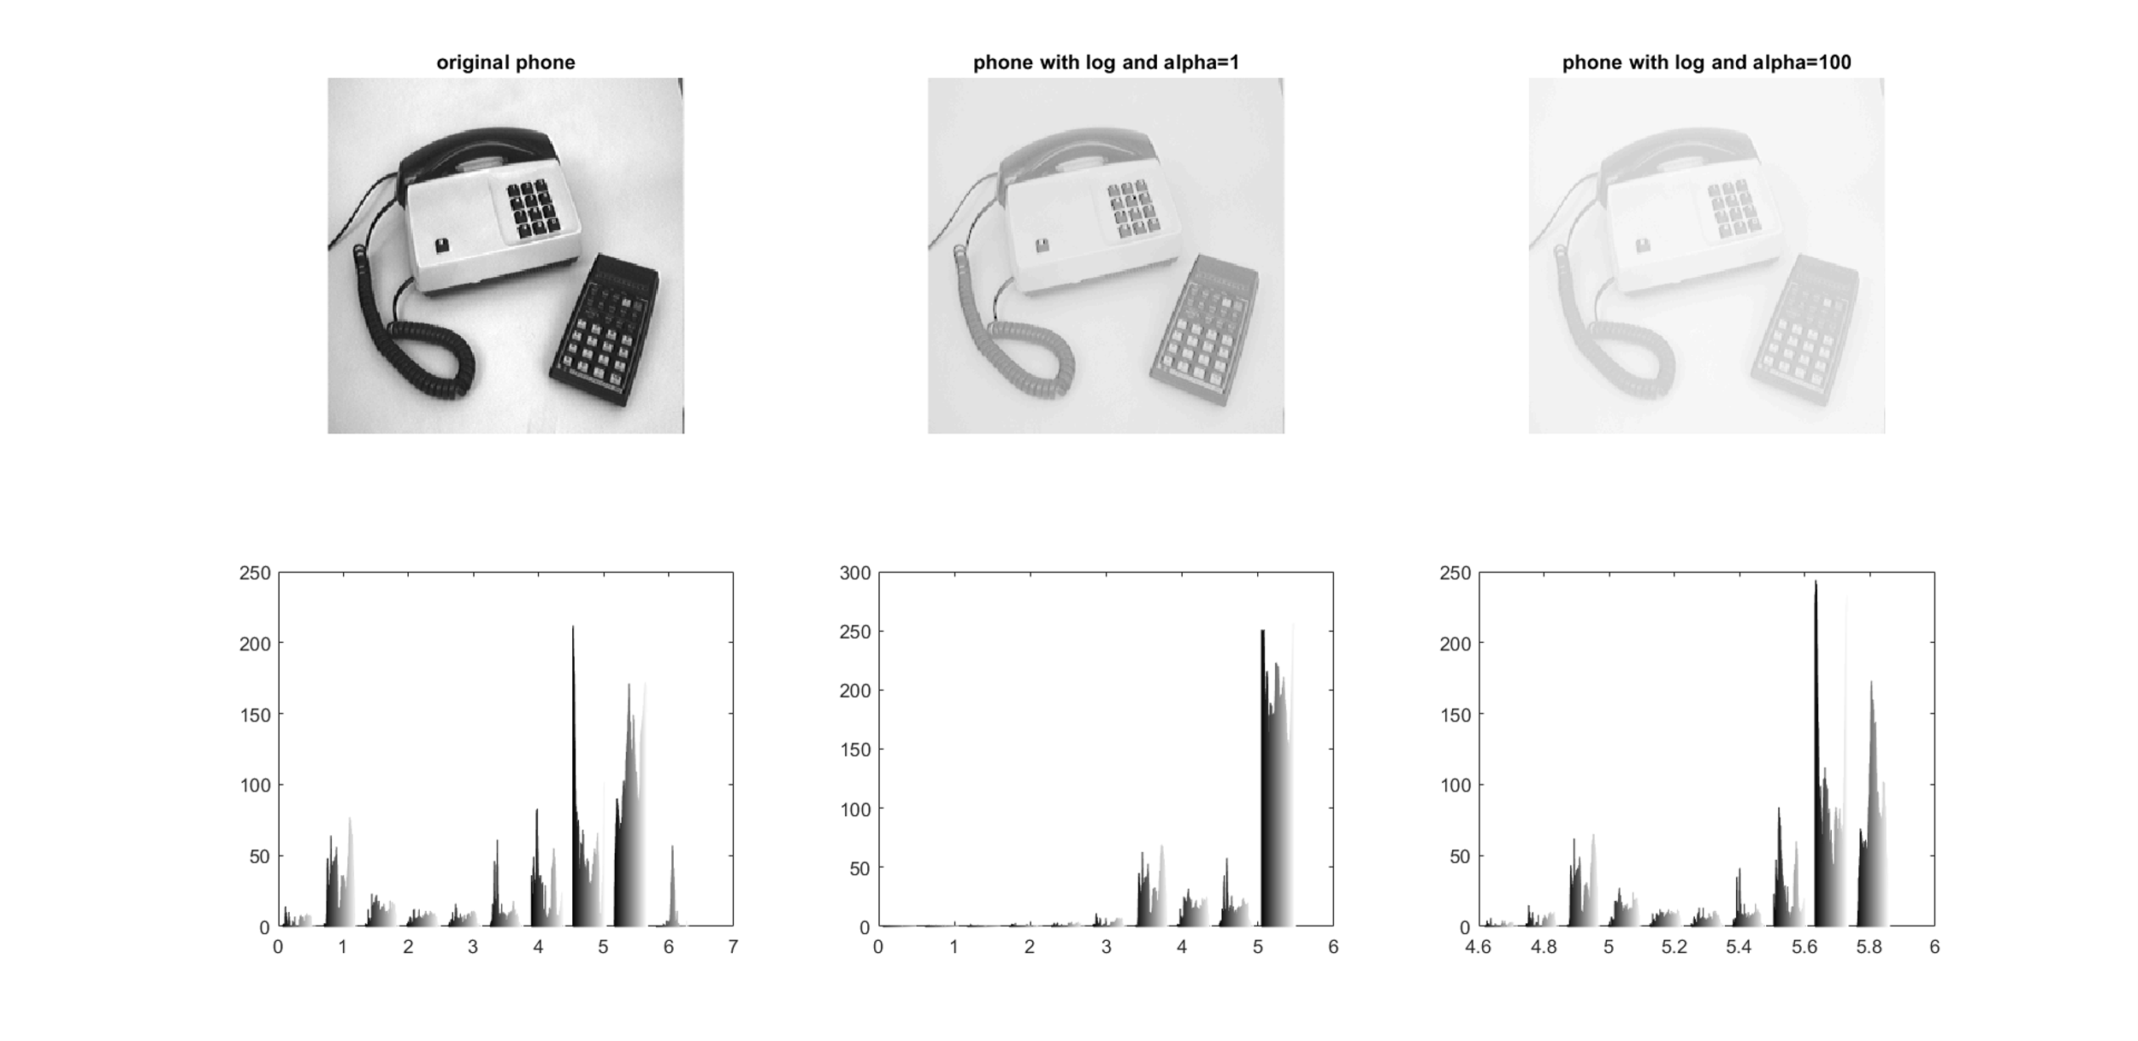

___________________________________________________________________________

**Question 9**: What conclusions can be drawn regarding linearity? from your observations can you derive a mathematical expression in the general case?

Answers:

The linear nature of the forier transform results in that adding images before computing the fourier transform gives the same result as adding imges together in the fourier domain.

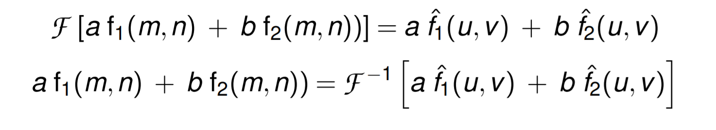

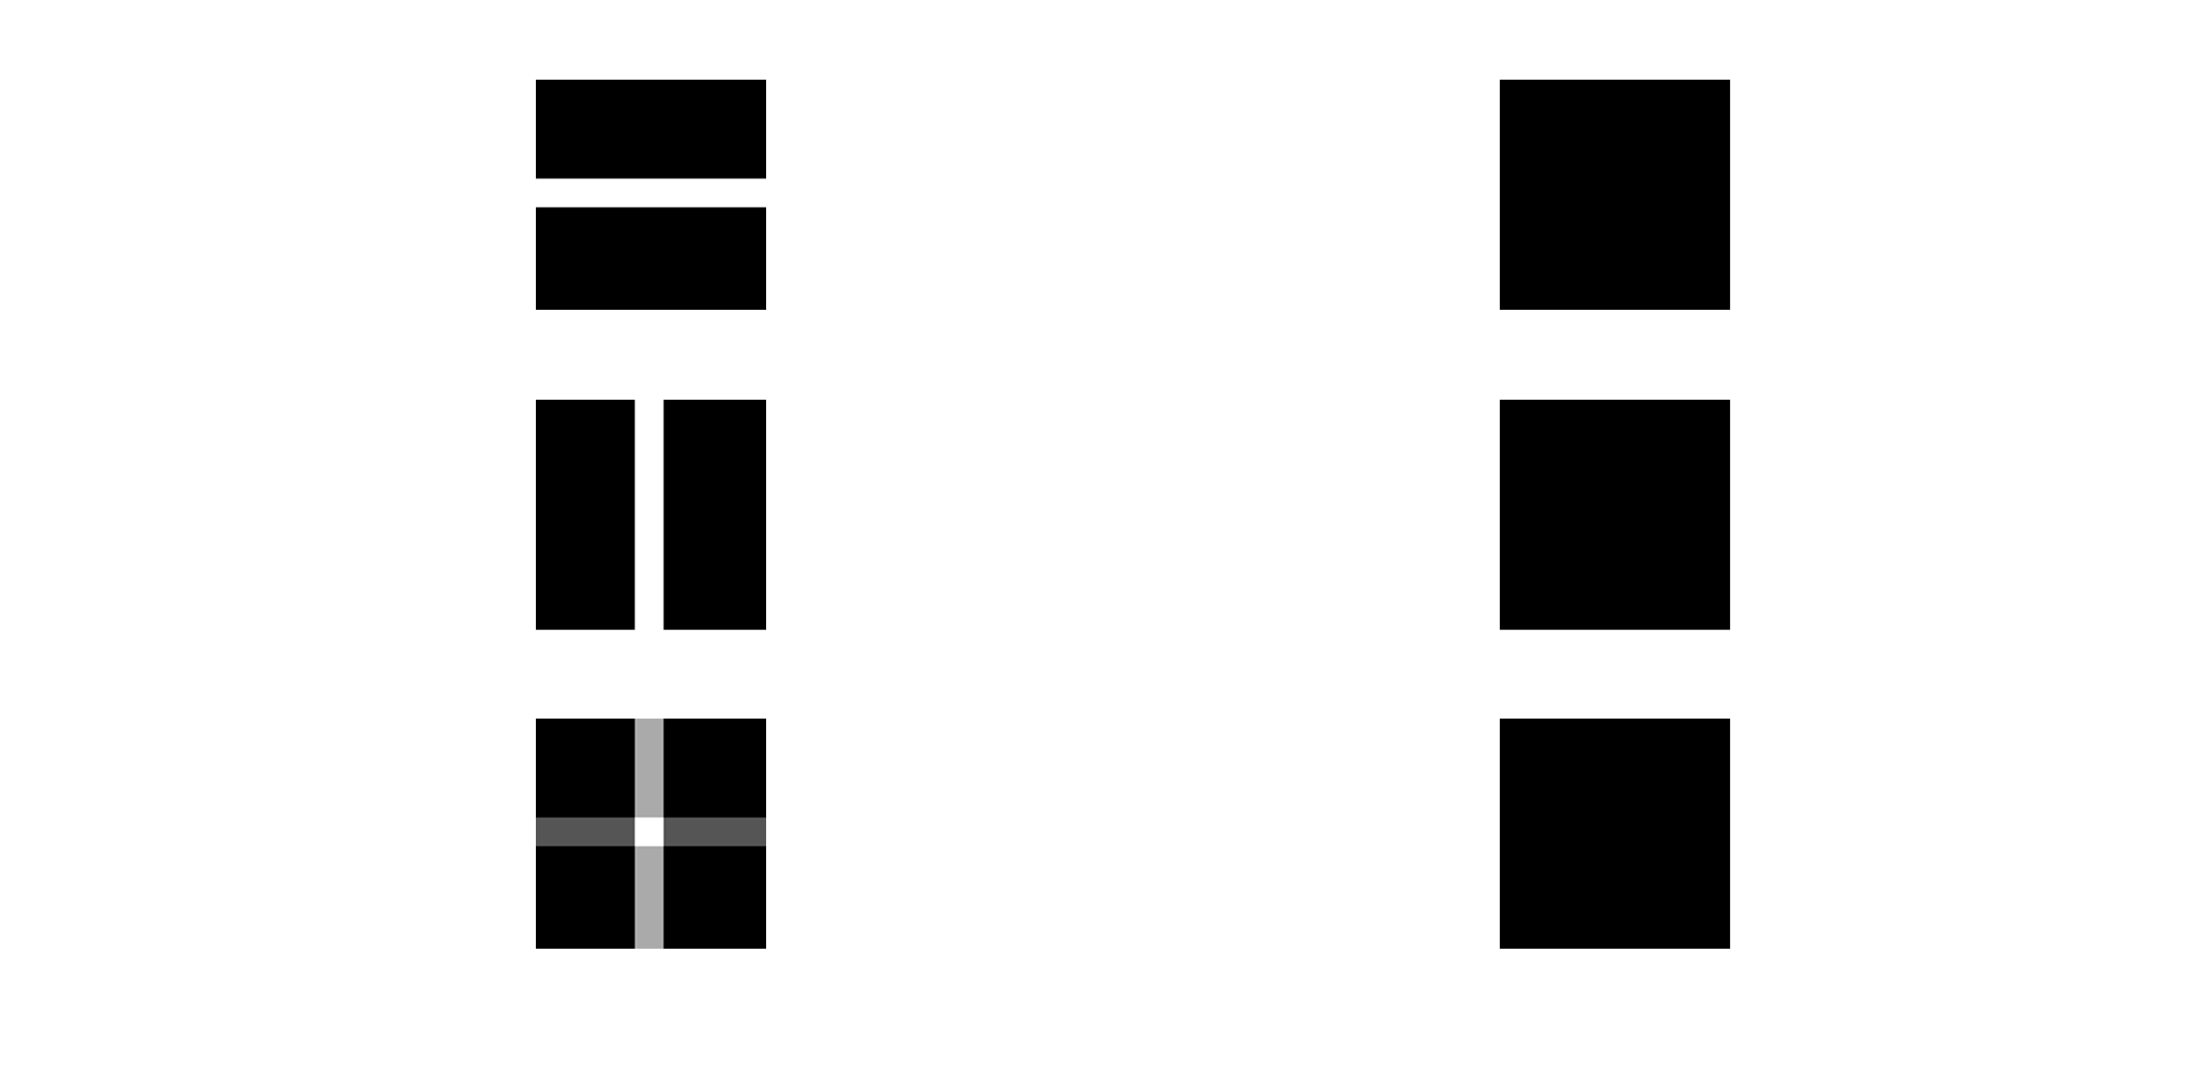

___________________________________________________________________________

**Question 10**: Are there any other ways to compute the last image? Remember what multiplication in Fourier domain equals to in the spatial domain! Perform these alternative computations in practice.

Answers:

*“In mathematics, the convolution theorem states that under suitable conditions the Fourier transform of a convolution of two signals is the pointwise product of their Fourier transforms. In other words, convolution in one domain (e.g., time domain) equals point-wise multiplication in the other domain (e.g., frequency domain).”- source.*

The code:

c = conv2(Fhat, Ghat)/sz.^2;

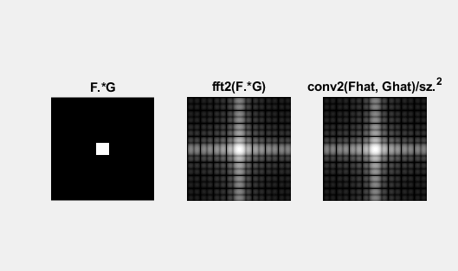

___________________________________________________________________________

**Question 11**: What conclusions can be drawn from comparing the results with those in the previous exercise? See how the source images have changed and analyze the effects of scaling.

Answers:

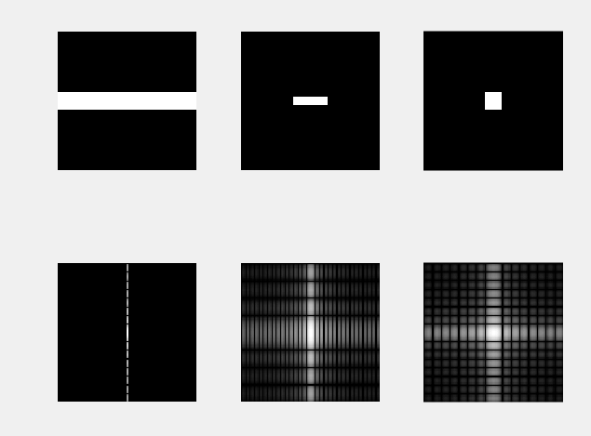

Scaling the x axis in the spatial domain leads to scaling the u (“y”) direction in the frequency domain We can see that the in ex the x axis, the length of the signal (square wave) that will be seen by the fourier transform increases, which means that the lowest frequency decreases, this can be seen in the y axis of the frequency plot. Compresion in spatial is expansion in foureir.

___________________________________________________________________________

**Question 12**: What can be said about possible similarities and differences? Hint: think of the frequencies and how they are affected by the rotation.

Answers:

When something is rotated in the spatial domain, it will also be rotated in the fourier-domain in the same direction.

We expect more high frequencys since when the picture is rotated, for example in the corners, which leads to more high frequencys in the fourier graph.

Frequencys exists in two dominating directions in the fourier image

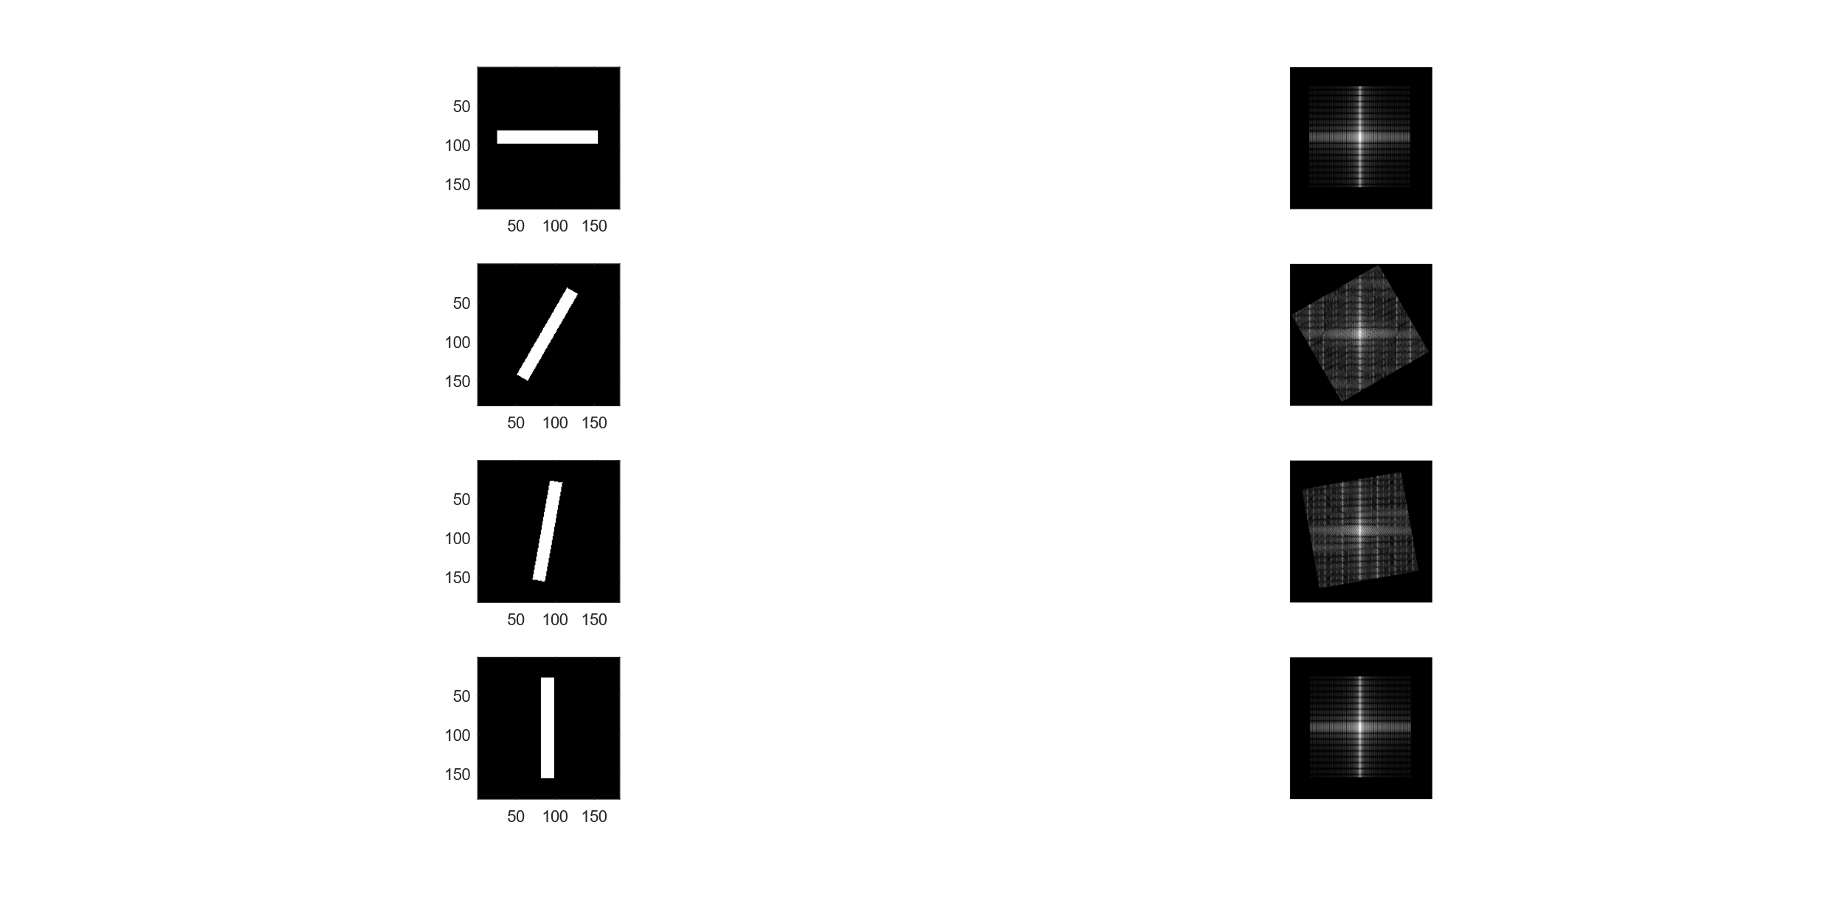

___________________________________________________________________________

**Question 13**: What information is contained in the phase and in the magnitude of the Fourier transform?

Answers:

The phase contains information about where things are located in the image, by containing the starting point for each sine wave, it determines where the edges are in the image, the amplitude contain the amount of each frequency that the image contain, and therefore effect the pixel intensity of the image (edges the difference between black and white).

___________________________________________________________________________

**Question 14**: Show the impulse response and variance for the above-mentioned t-values. What are the variances of your discretized Gaussian kernel for t = 0.1, 0.3, 1.0, 10.0 and

100.0?

Answers:

|  |  |  |
| --- | --- | --- |
| t: | Coveraince matrix: | Impulse response: |
| 0.1 | 0.0133 0.0000  0.0000 0.0133 |  |
| 0.3 | 0.2811 0.0000  0.0000 0.2811 |  |
| 1.0 | 1.0000 0.0000  0.0000 1.0000 |  |
| 10.0 | 10.0000 0.0000  0.0000 10.0000 |  |
| 100.0 | 100.0000 0.0000  0.0000 100.0000 |  |

___________________________________________________________________________

**Question 15**: Are the results different from or similar to the estimated variance? How does the result correspond to the ideal continuous case? Lead: think of the relation between spatial and Fourier domains for different values of t.

Answers:

The results are similar to the estimated variance. We can see the result is not as good when using small t values and the variance is small, this could be explained by the fact that the gausian disrobution is “sampled” and a small variance leads to that a large portion of the distribution has to be represented by a small amount of samples, which leads to less exact results. The distribution becomes “less” gausian shaped.

___________________________________________________________________________

**Question 16**: Convolve a couple of images with Gaussian functions of different variances (like t = 1.0, 4.0, 16.0, 64.0 and 256.0) and present your results. What effects can you observe?

Answers:

The blur increases when the variance increases. This is because a higher variance leads to a lower cutoff frequency. A high variance in the spatial domain in a low variance in the frequency domain.

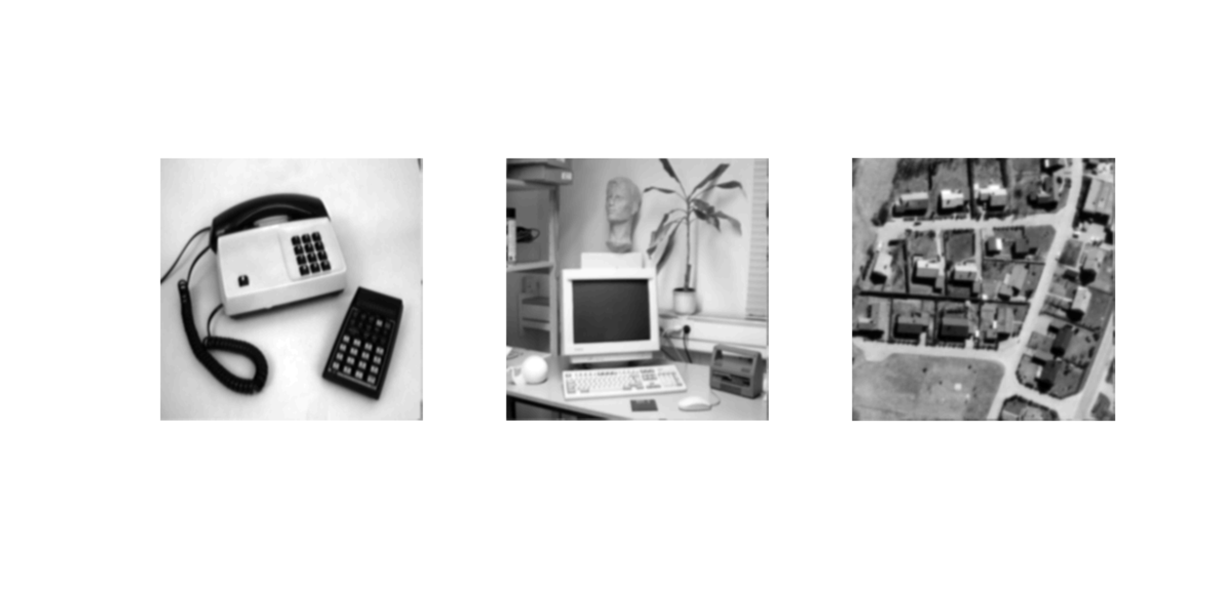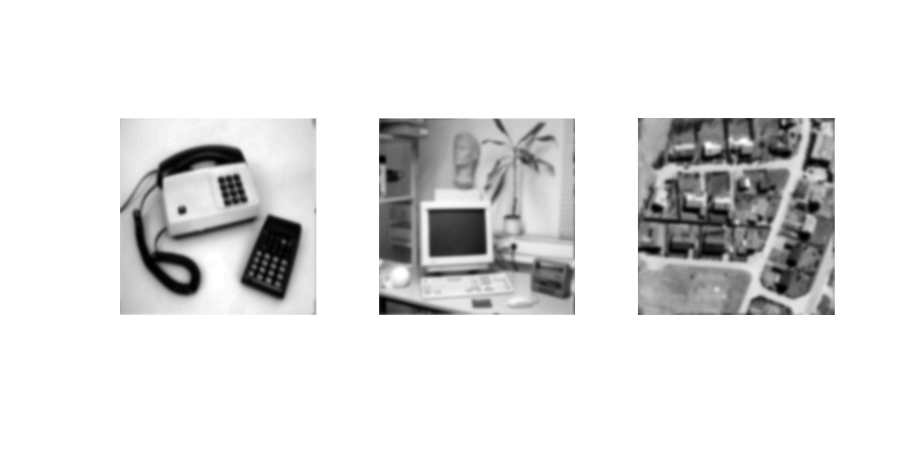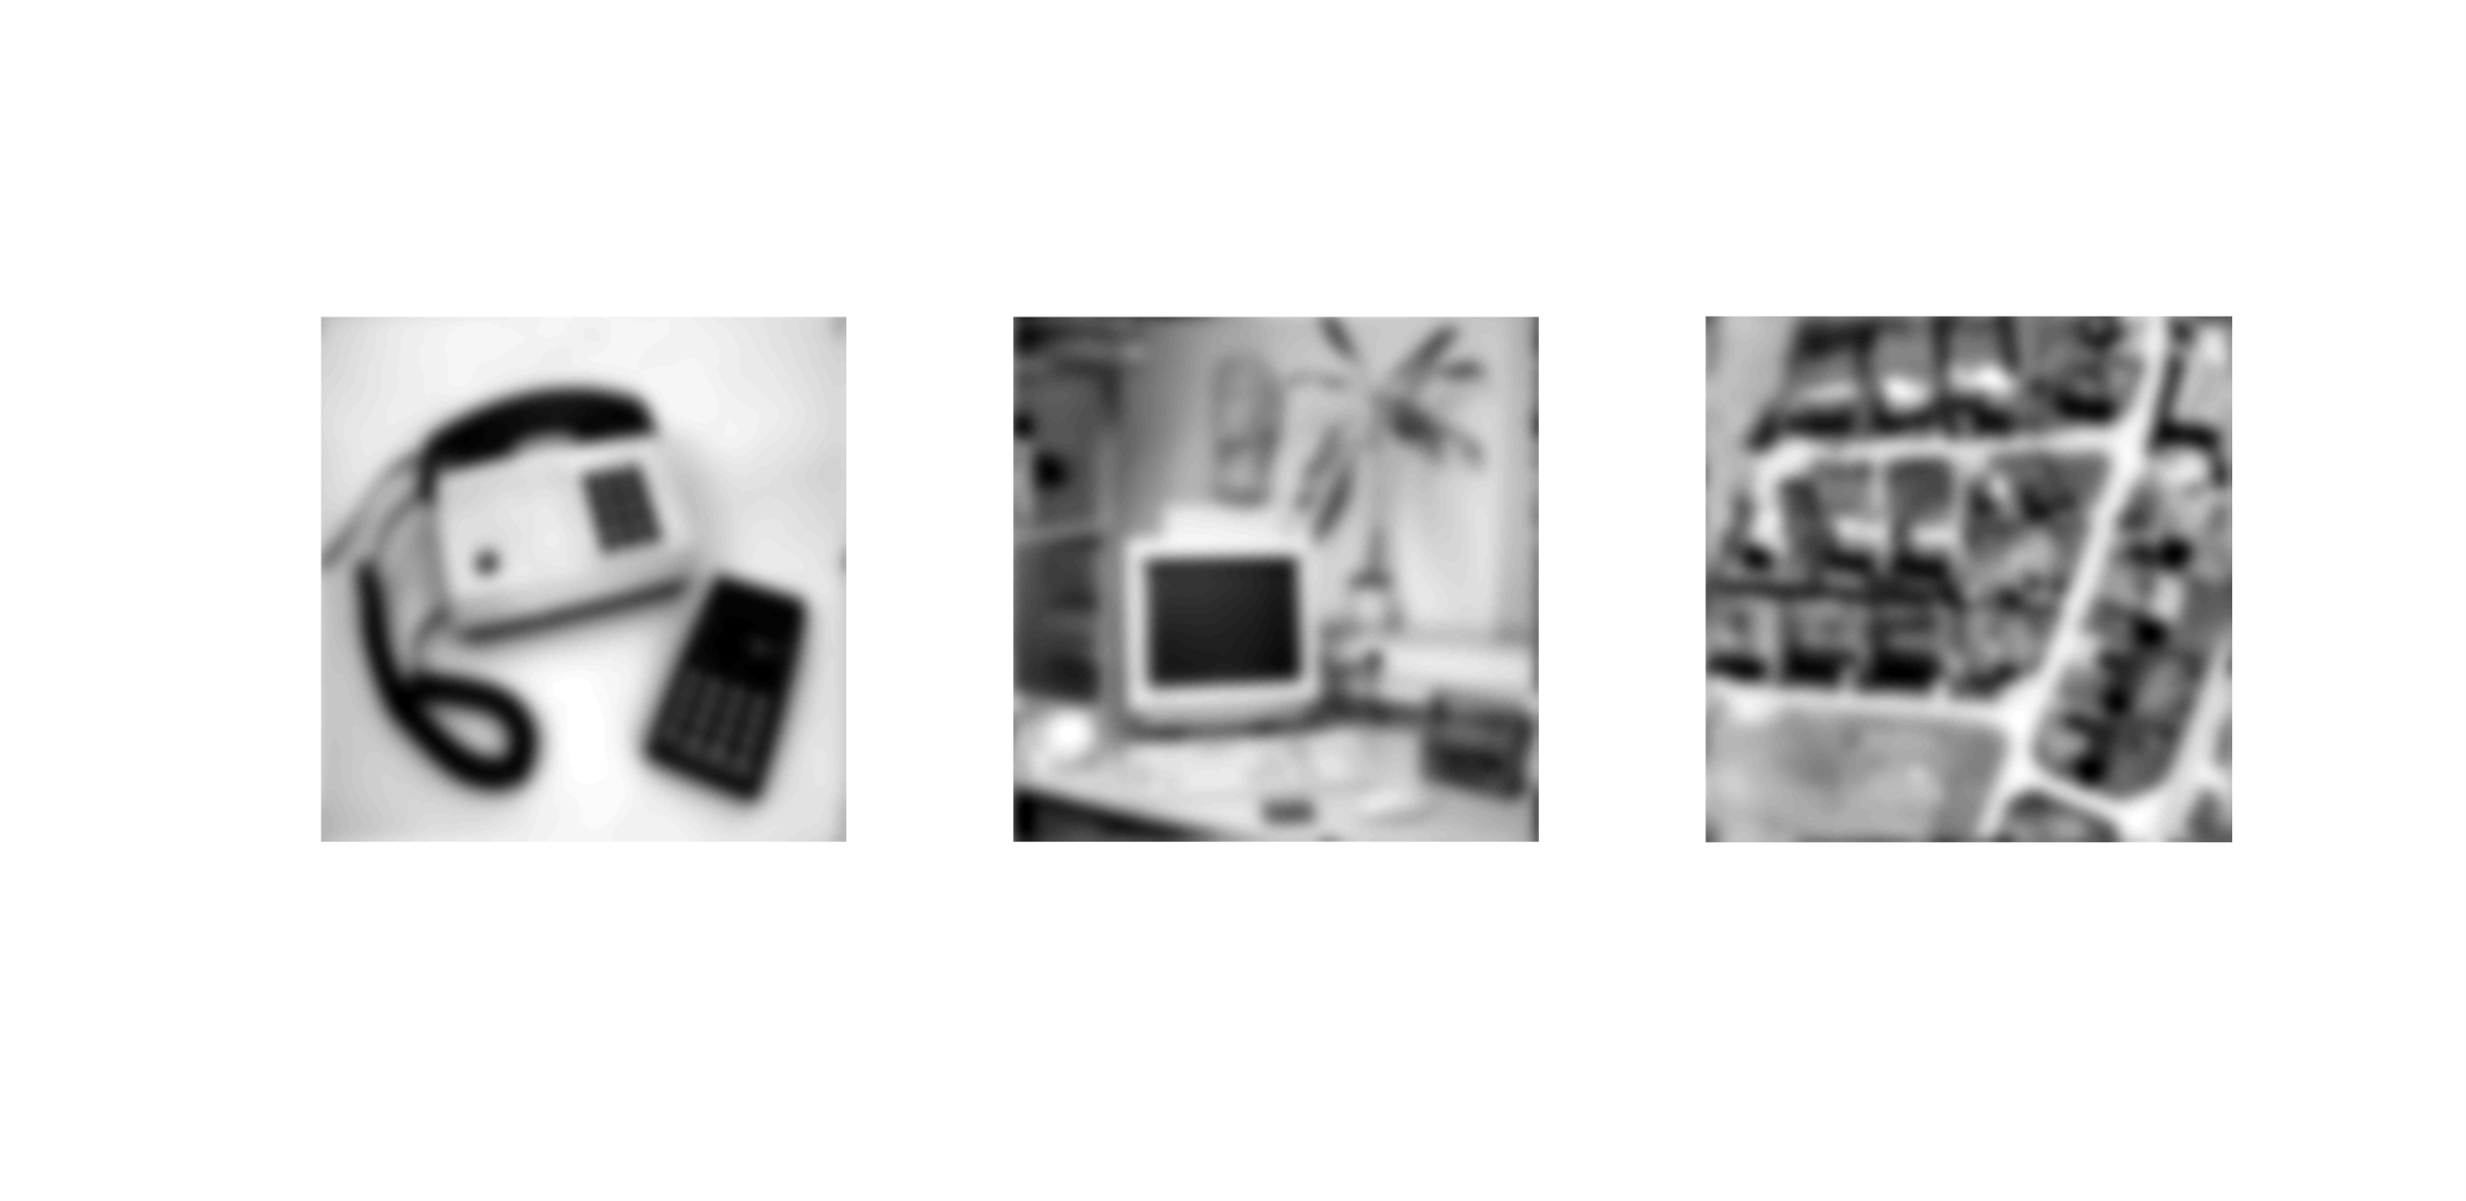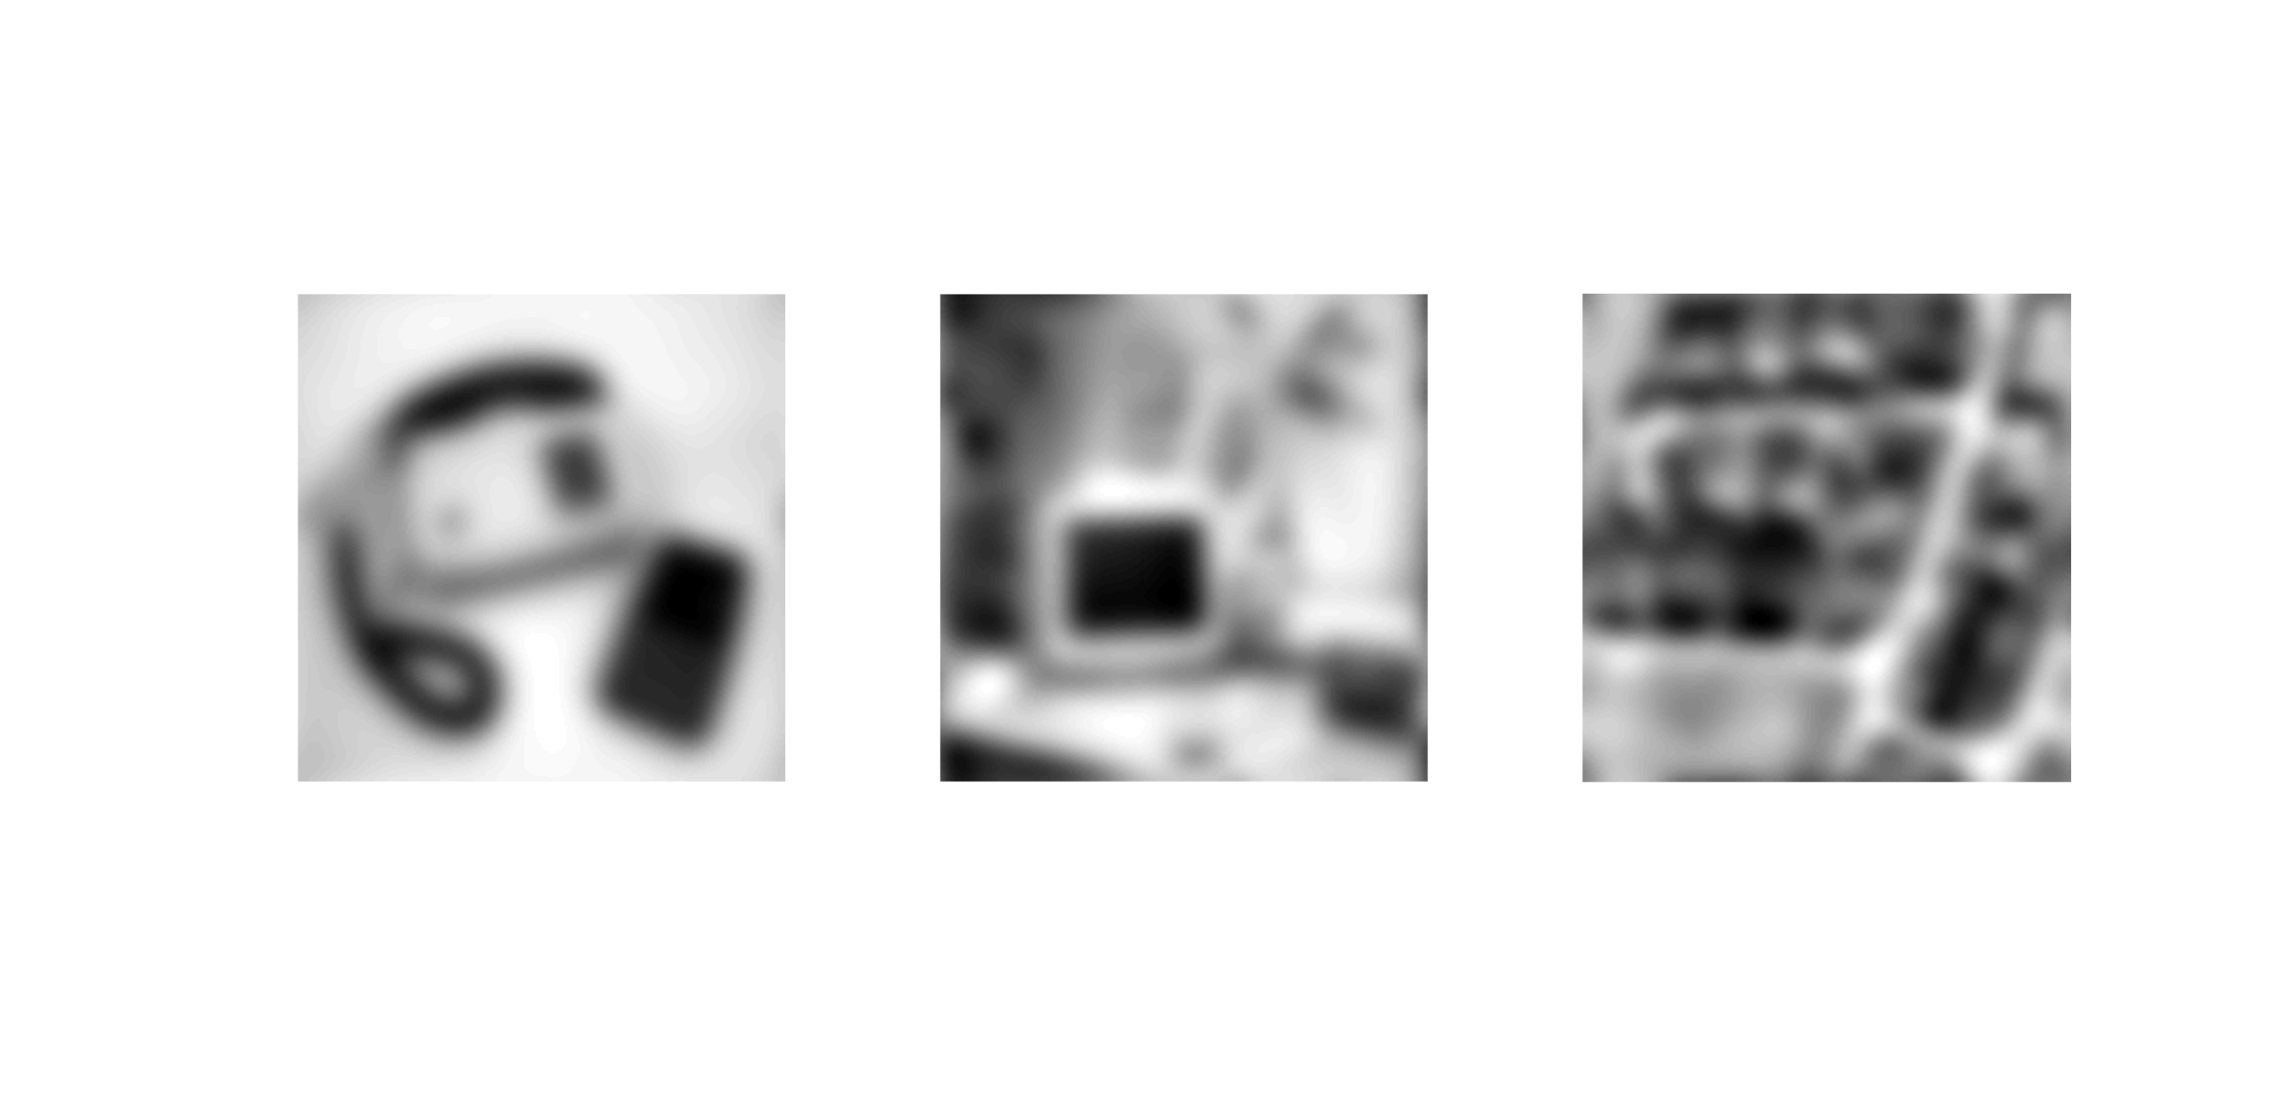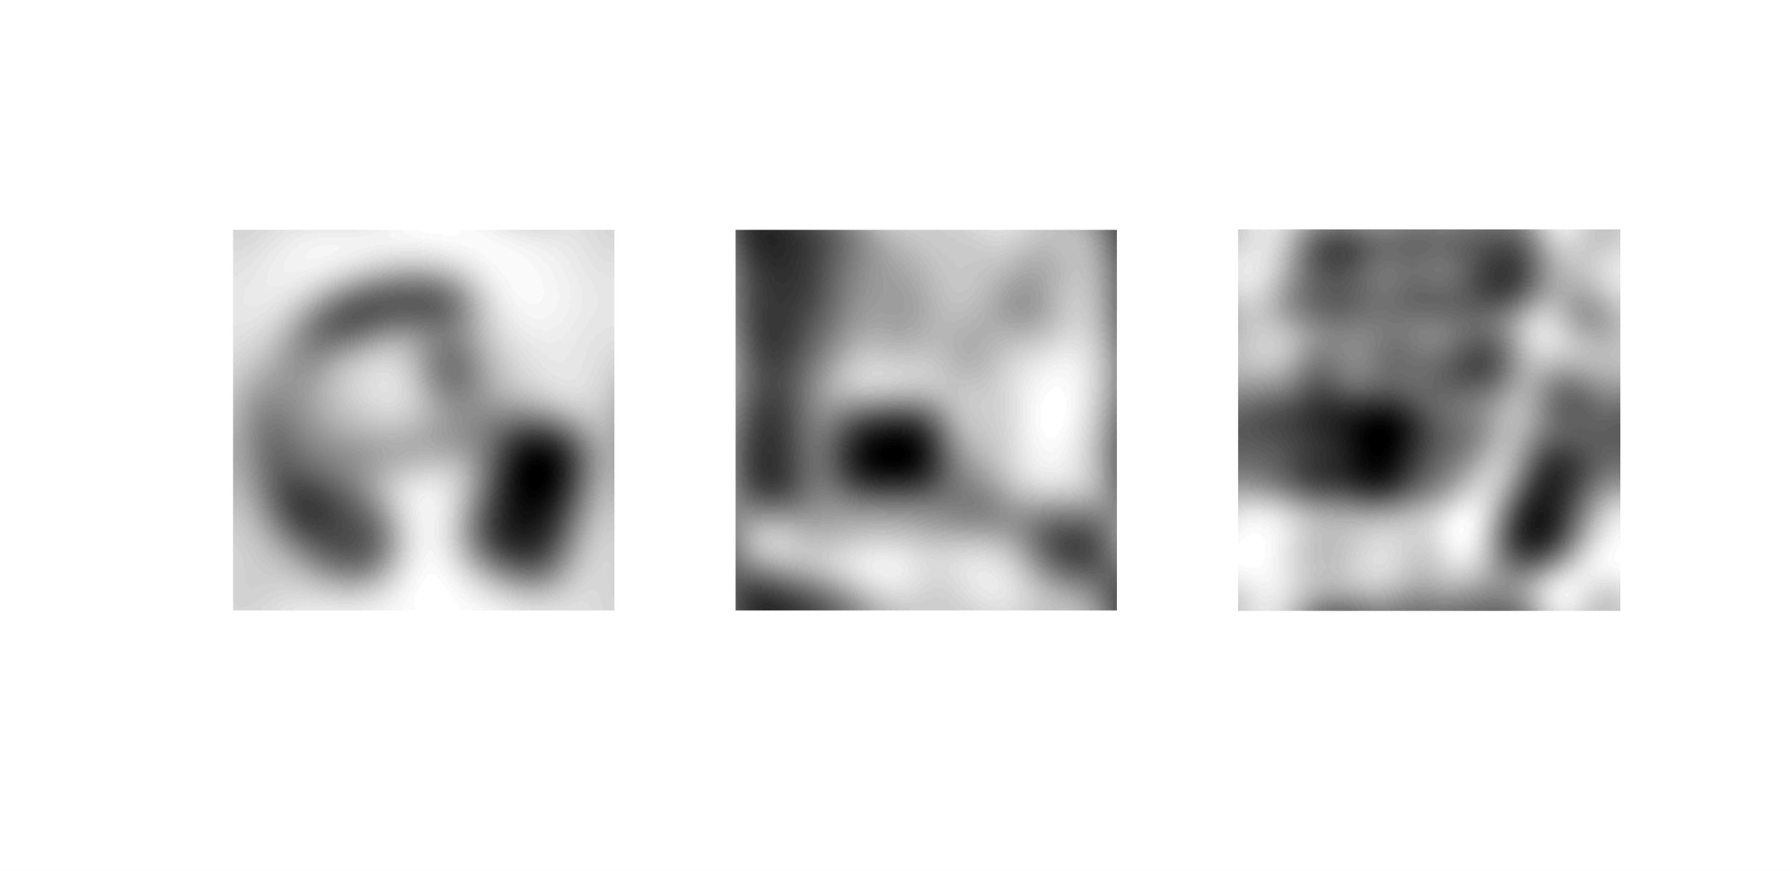

___________________________________________________________________________

**Question 17**: What are the positive and negative effects for each type of filter? Describe what you observe and name the effects that you recognize. How do the results depend on the filter parameters? Illustrate with Matlab figure(s).

Answers:

## Gaussian for salt and pepper:

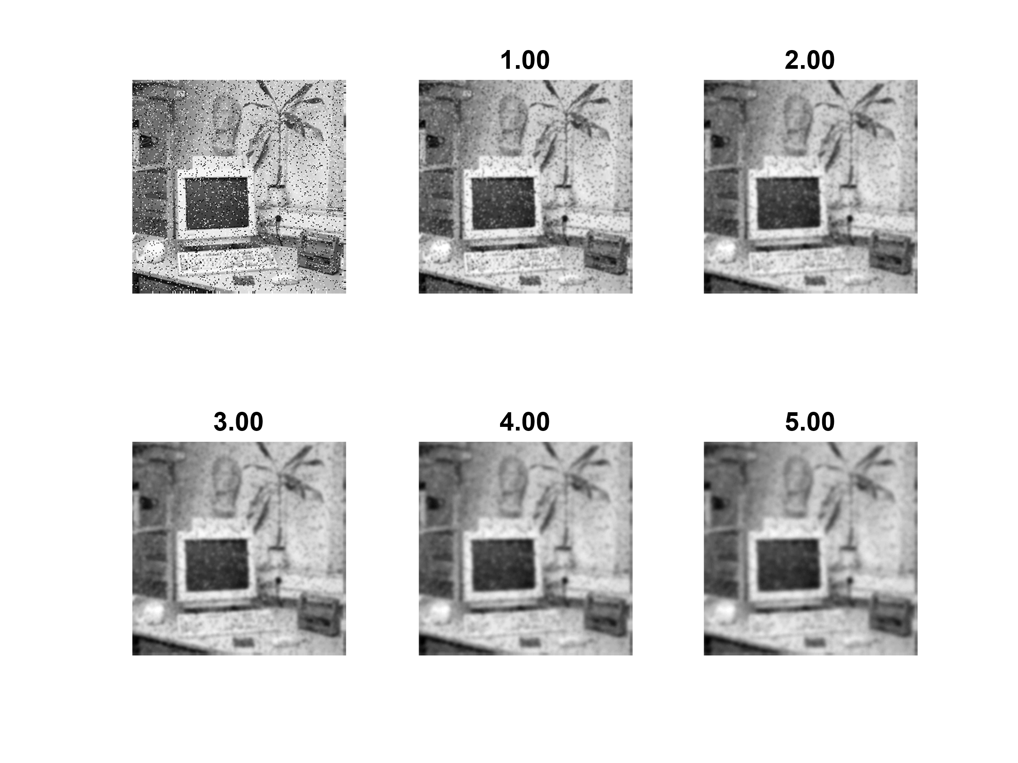

## Gaussian for gaussian noise:

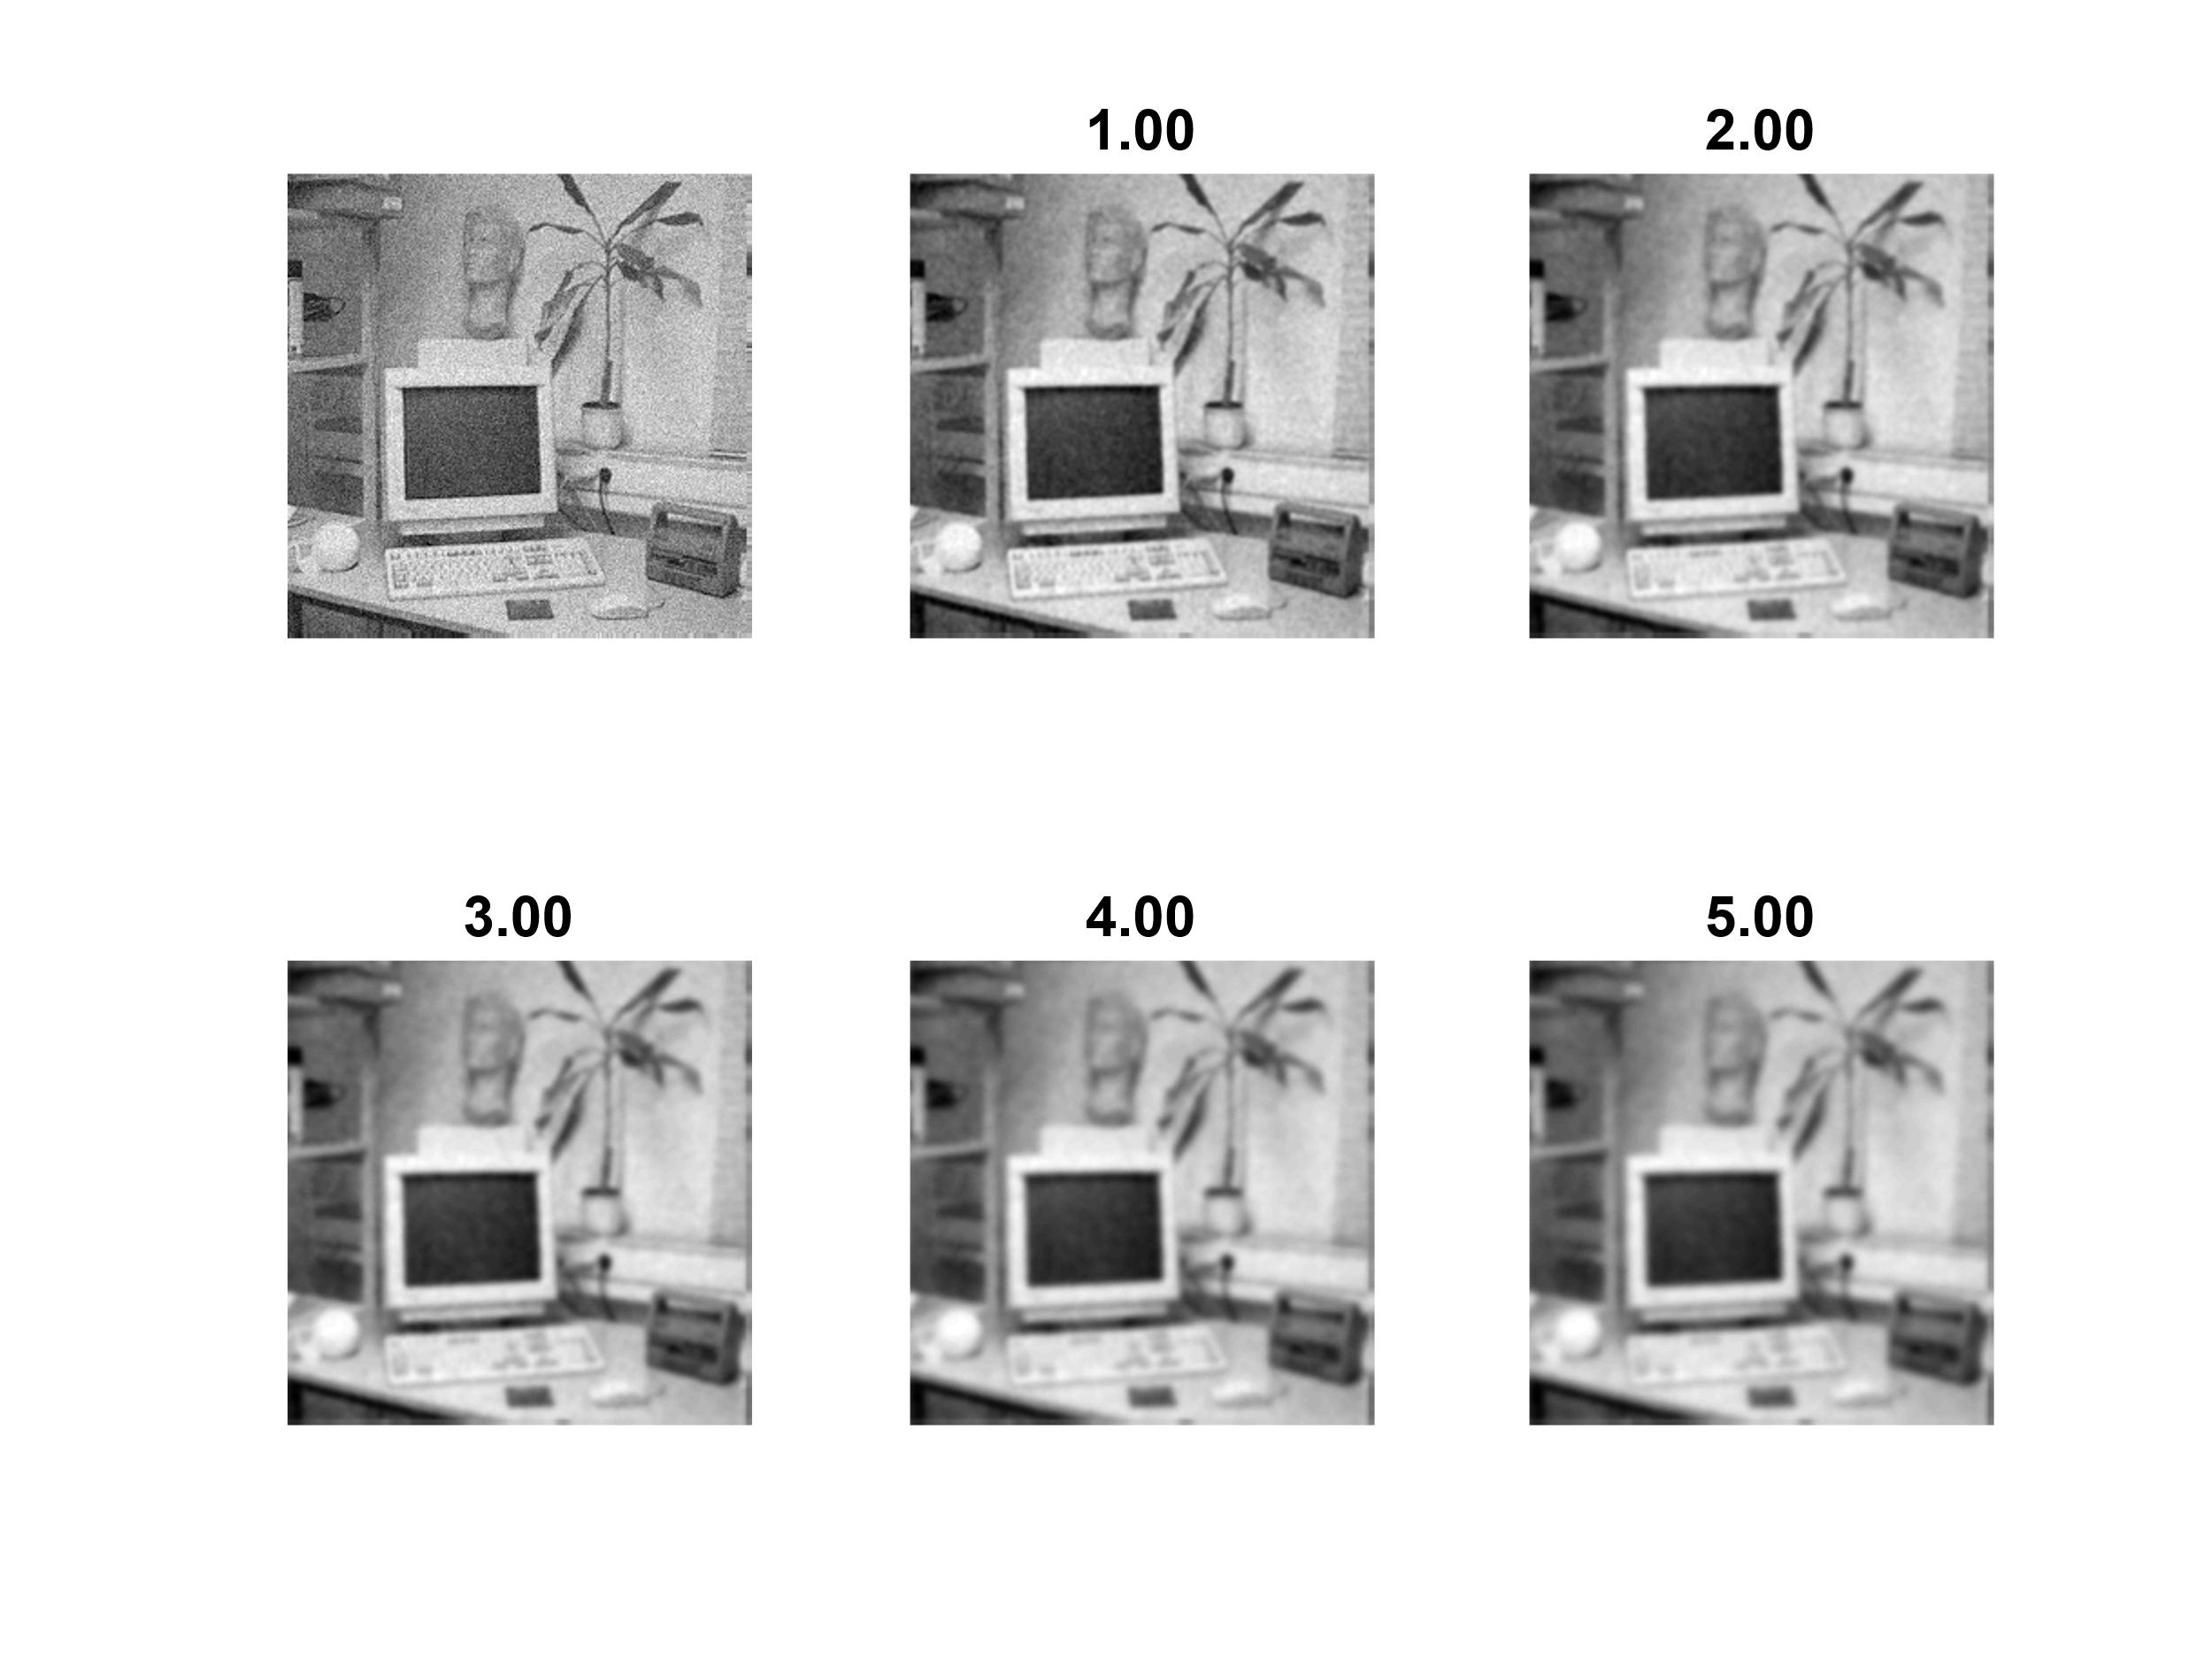

## Median for gaussian noise:

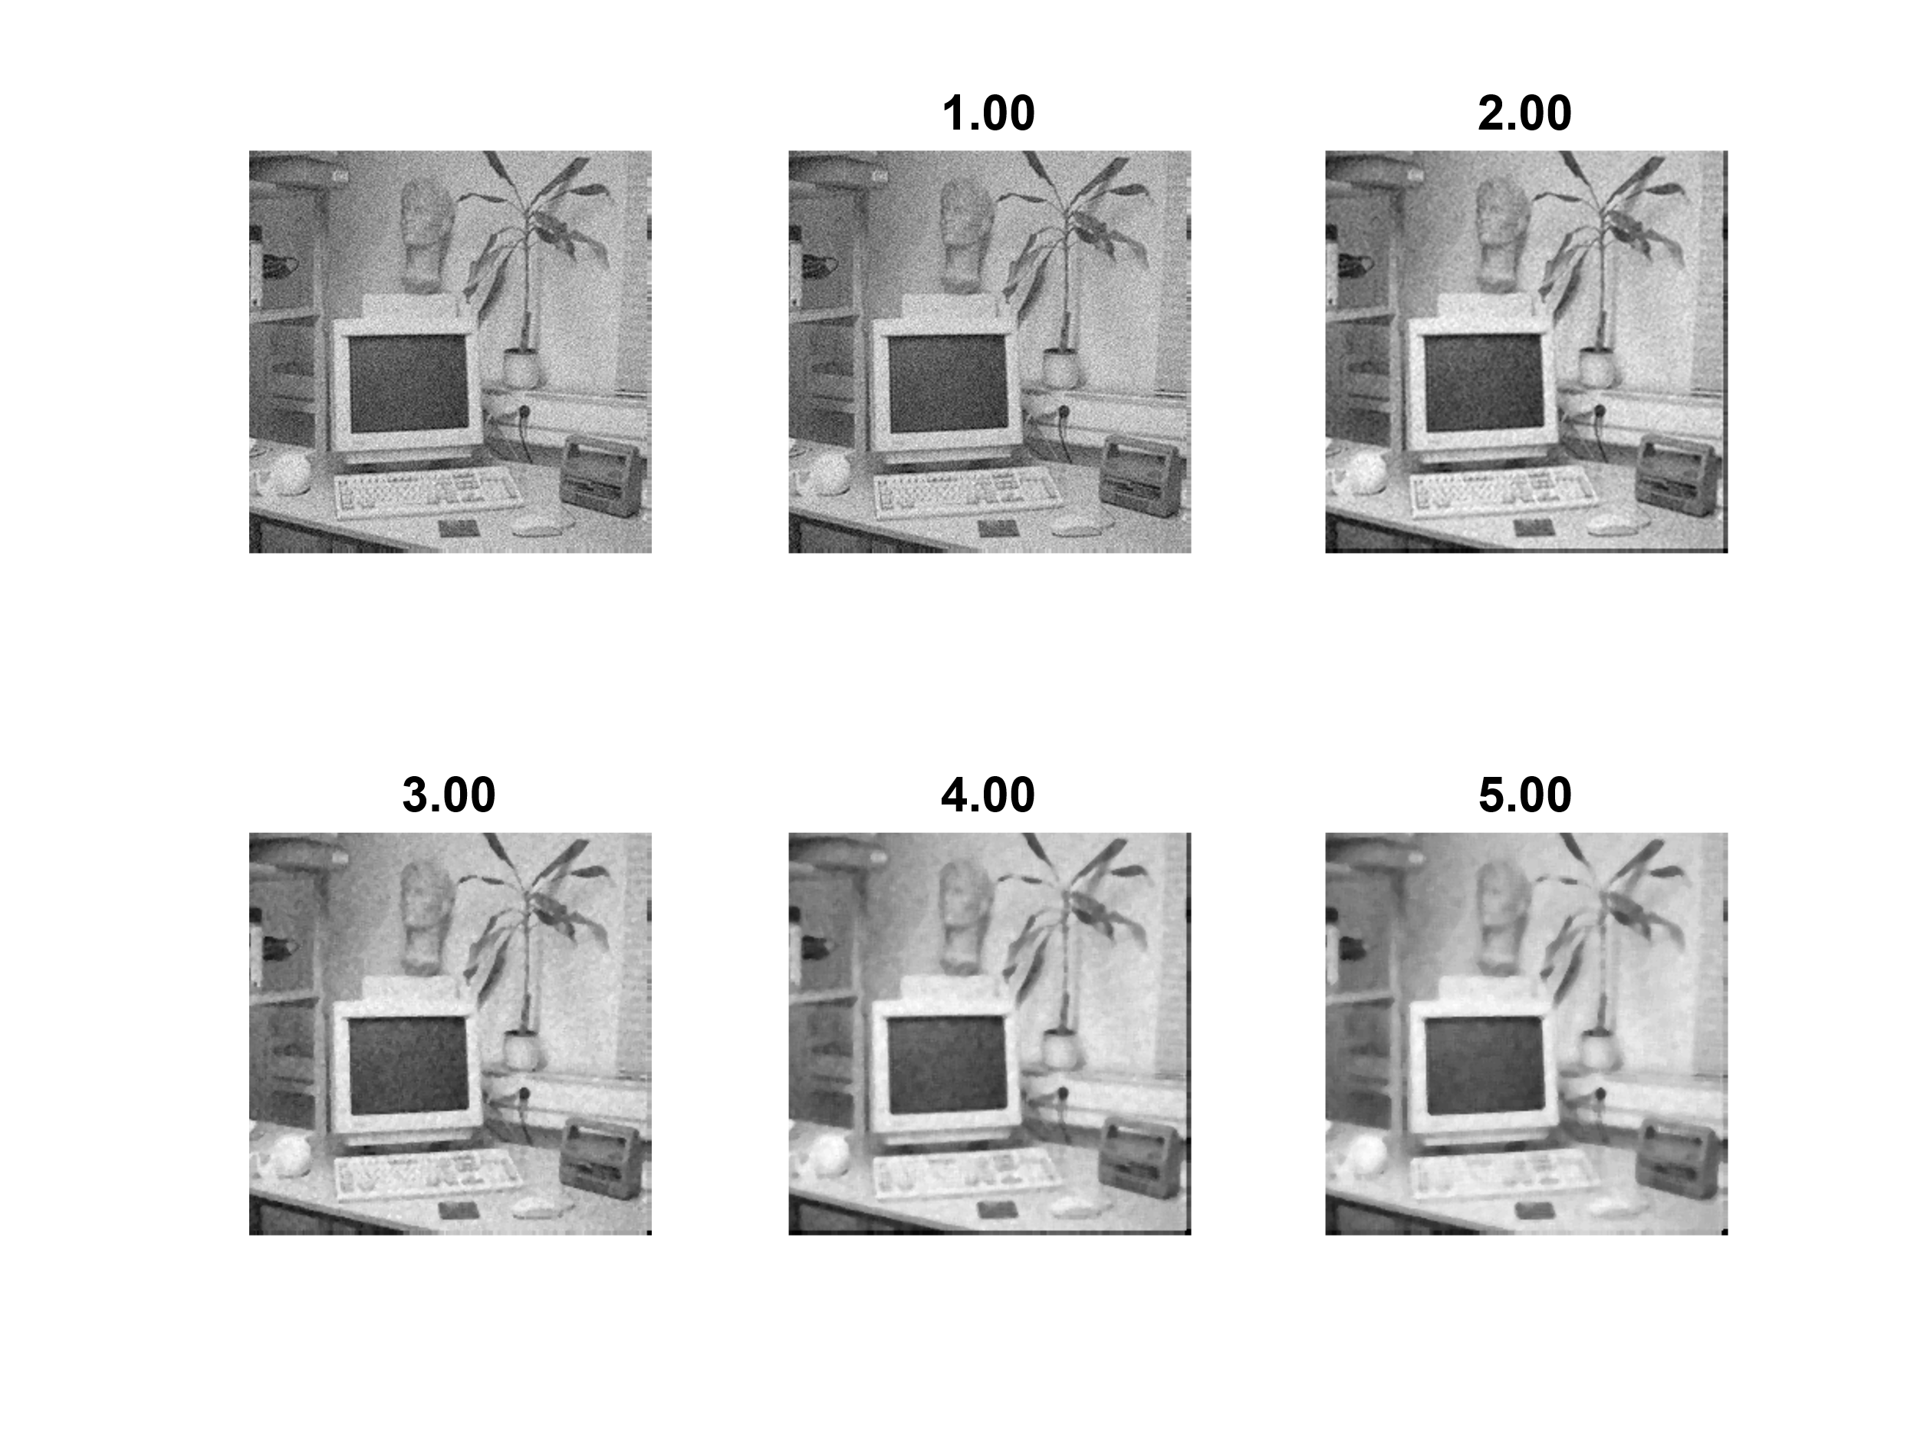

## Median for salt and pepper noise:

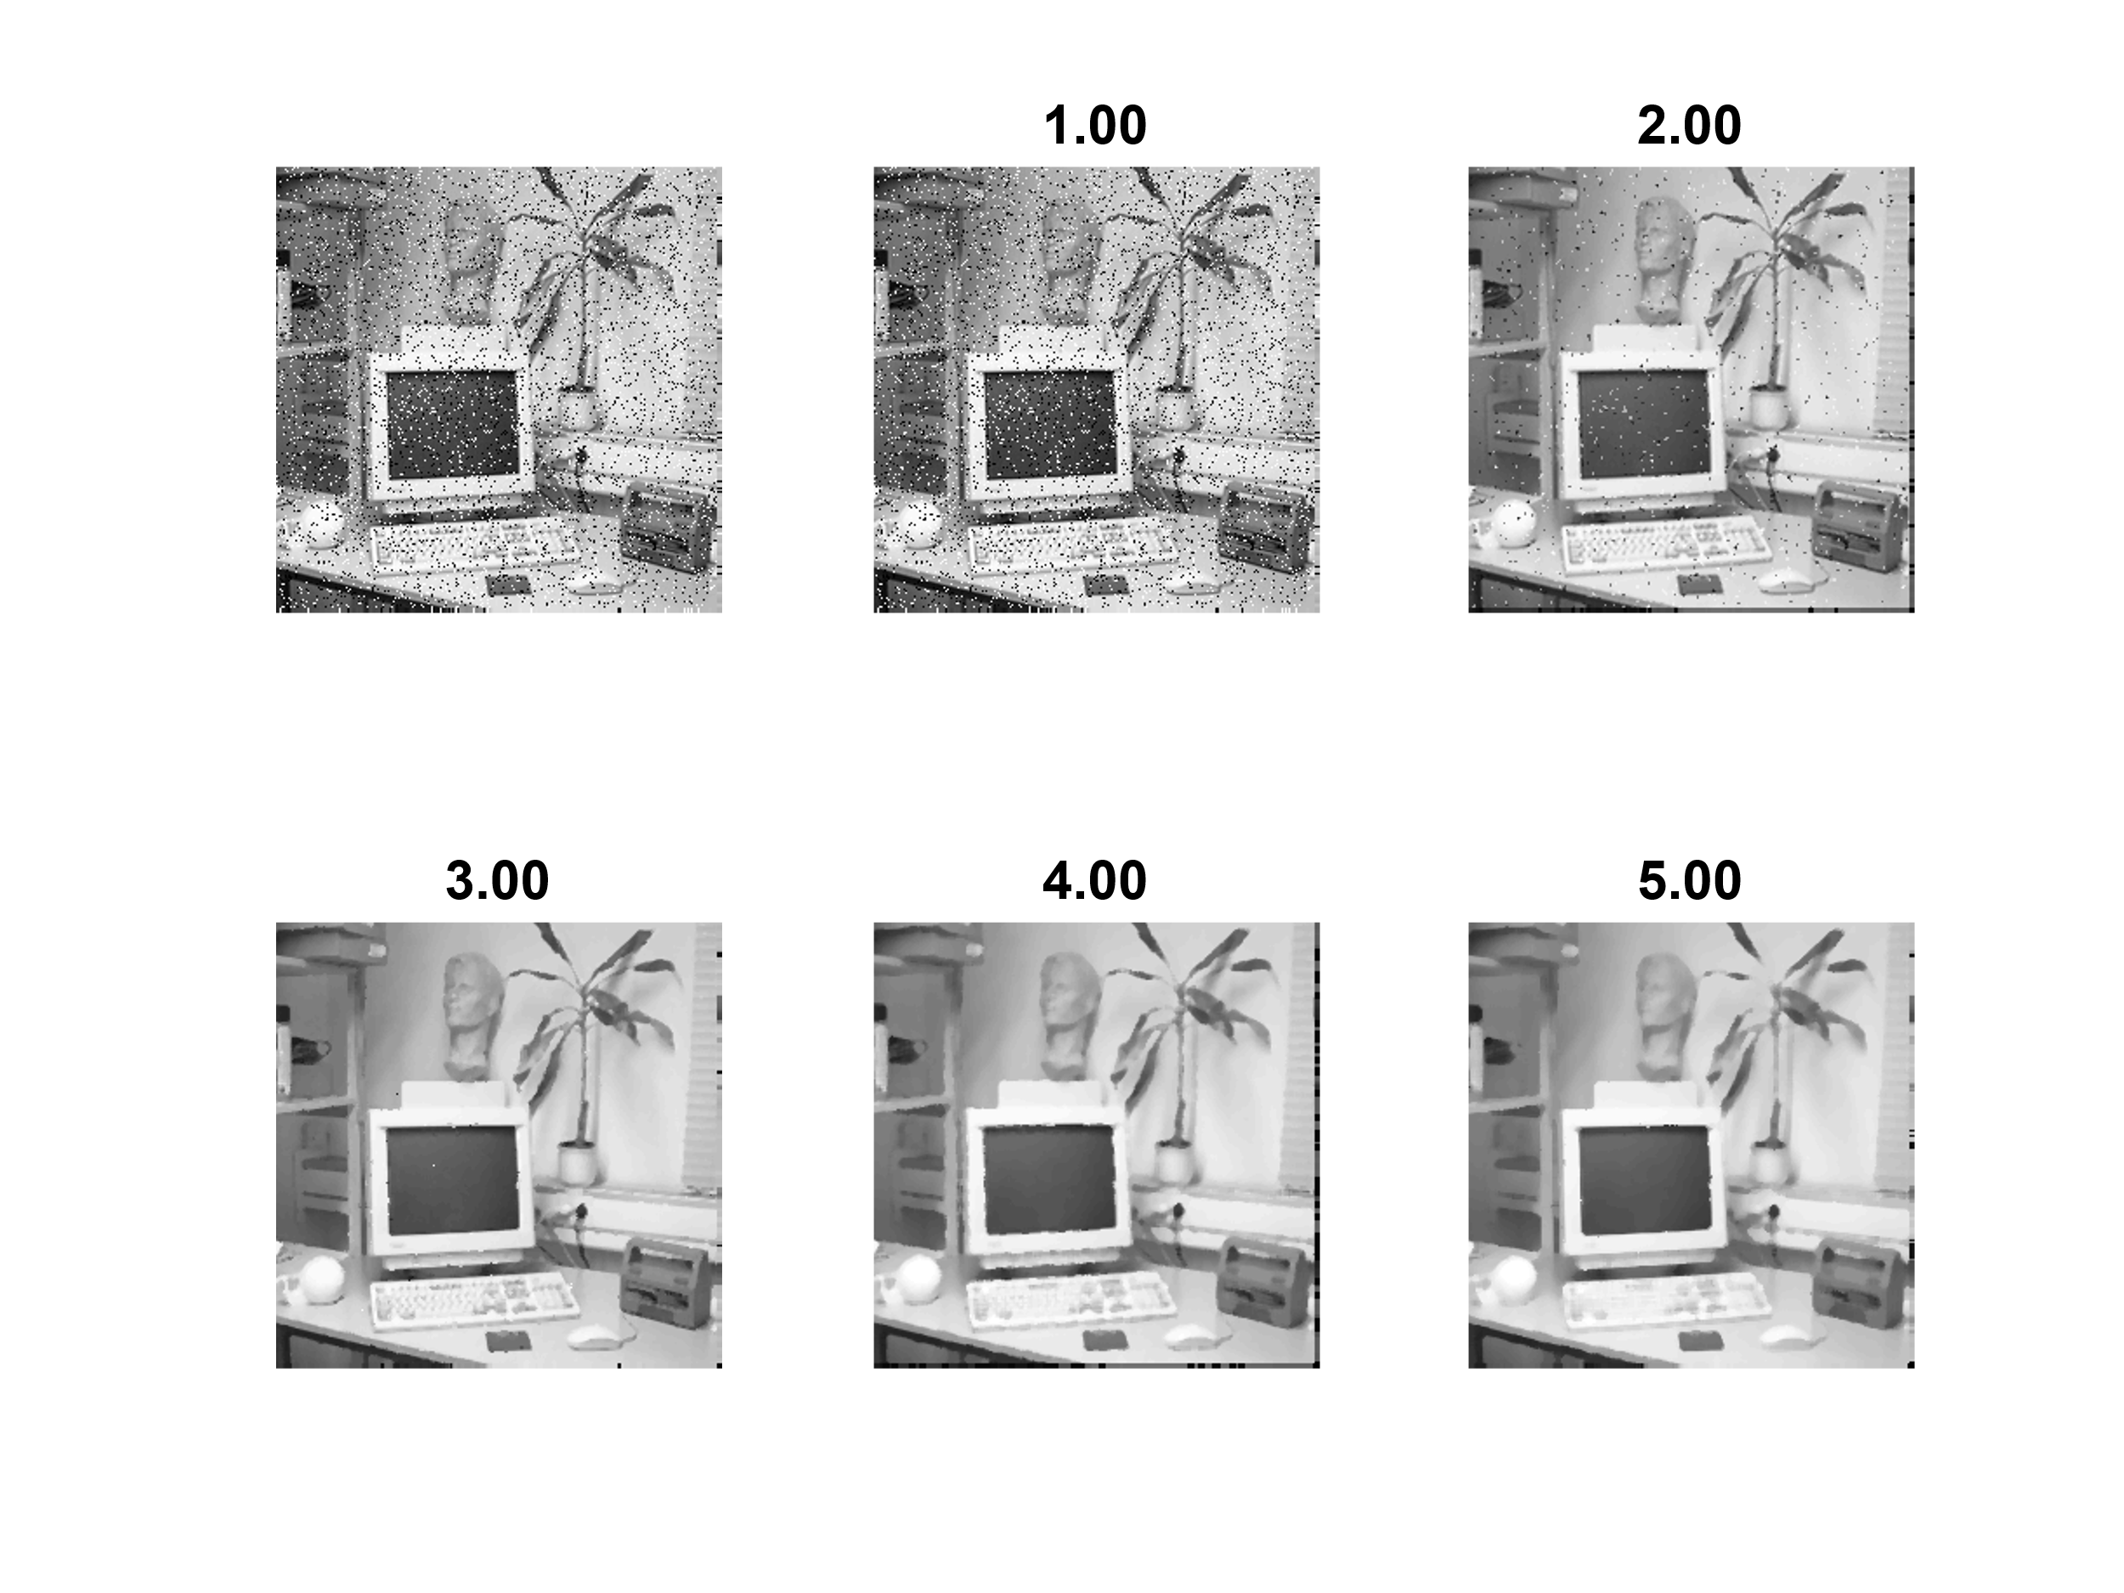

## Ideal for salt and pepper noise:

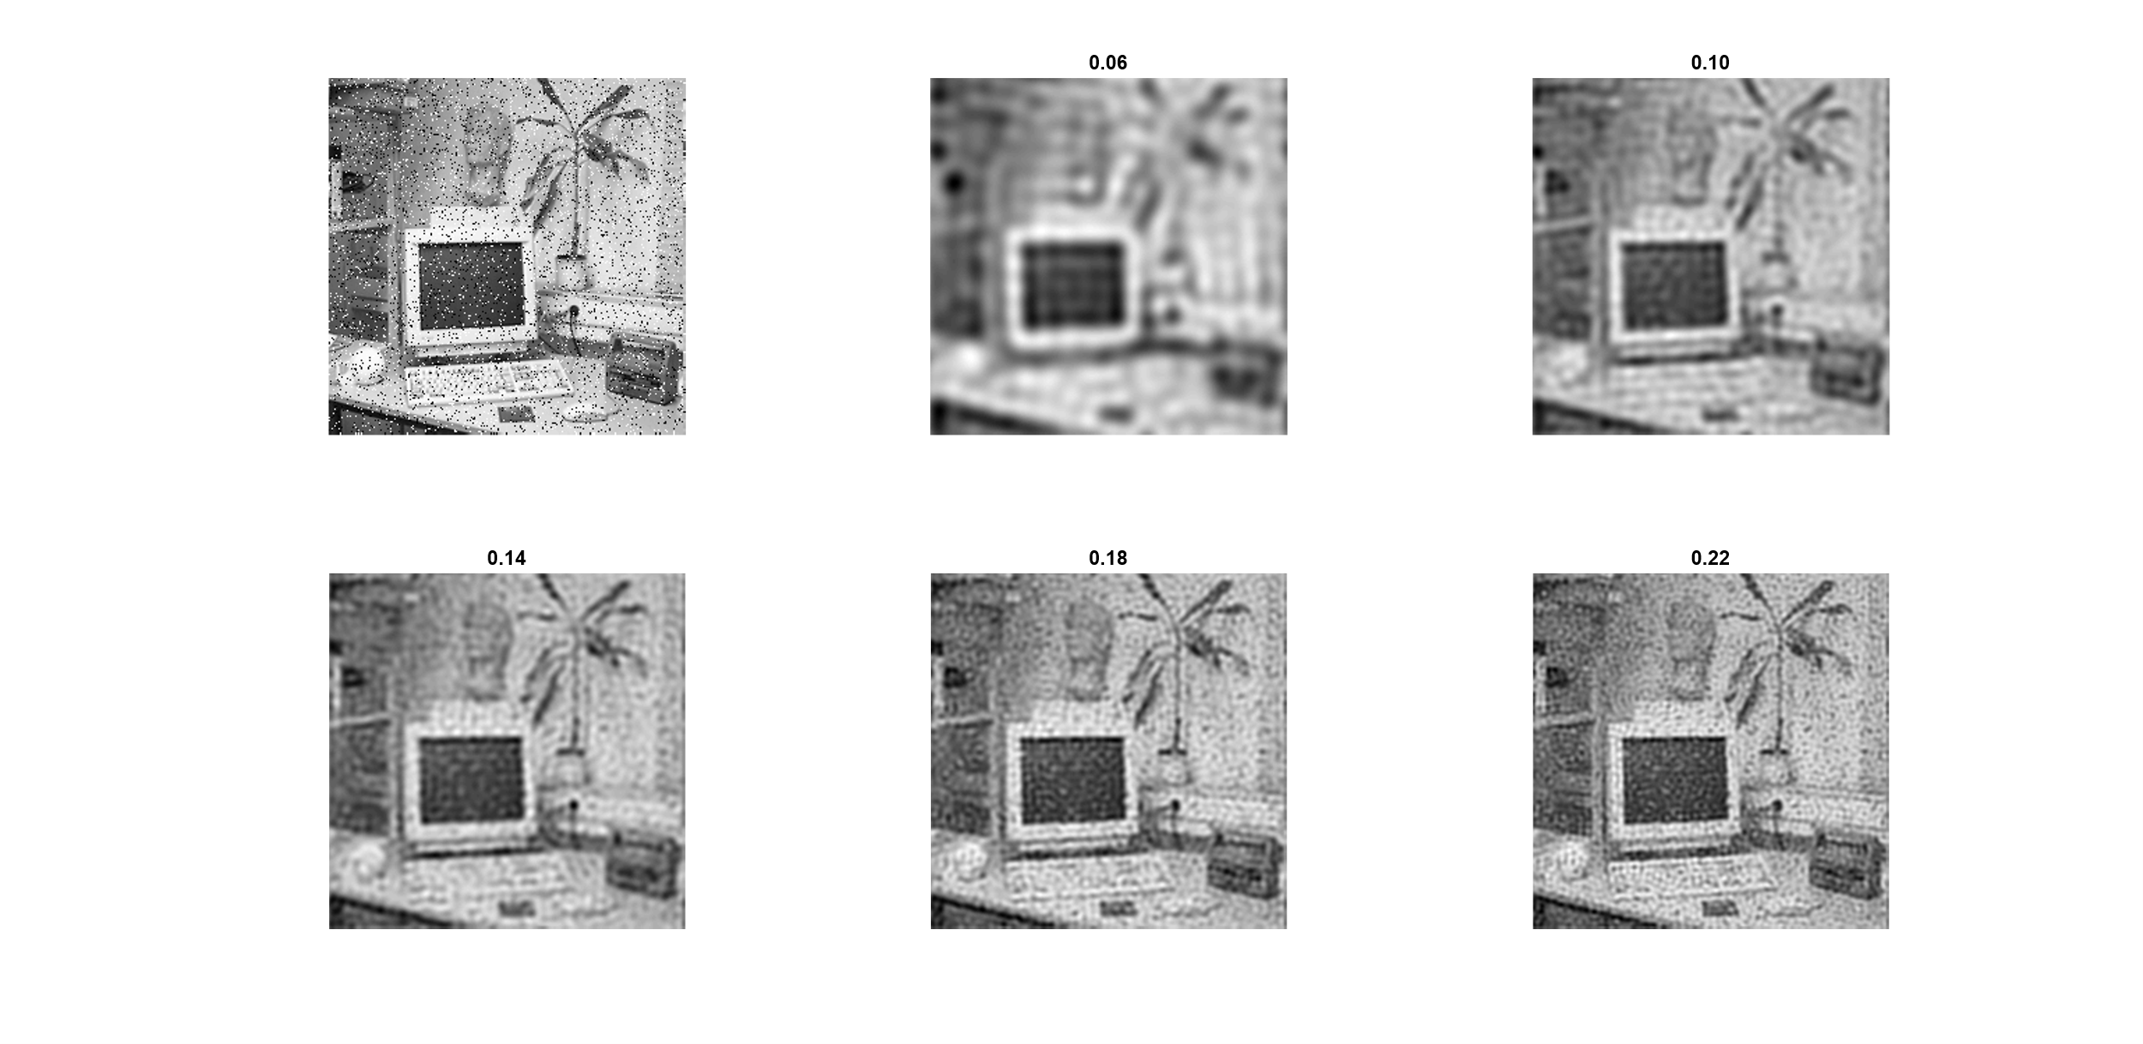

## Ideal for Gaussian noise:

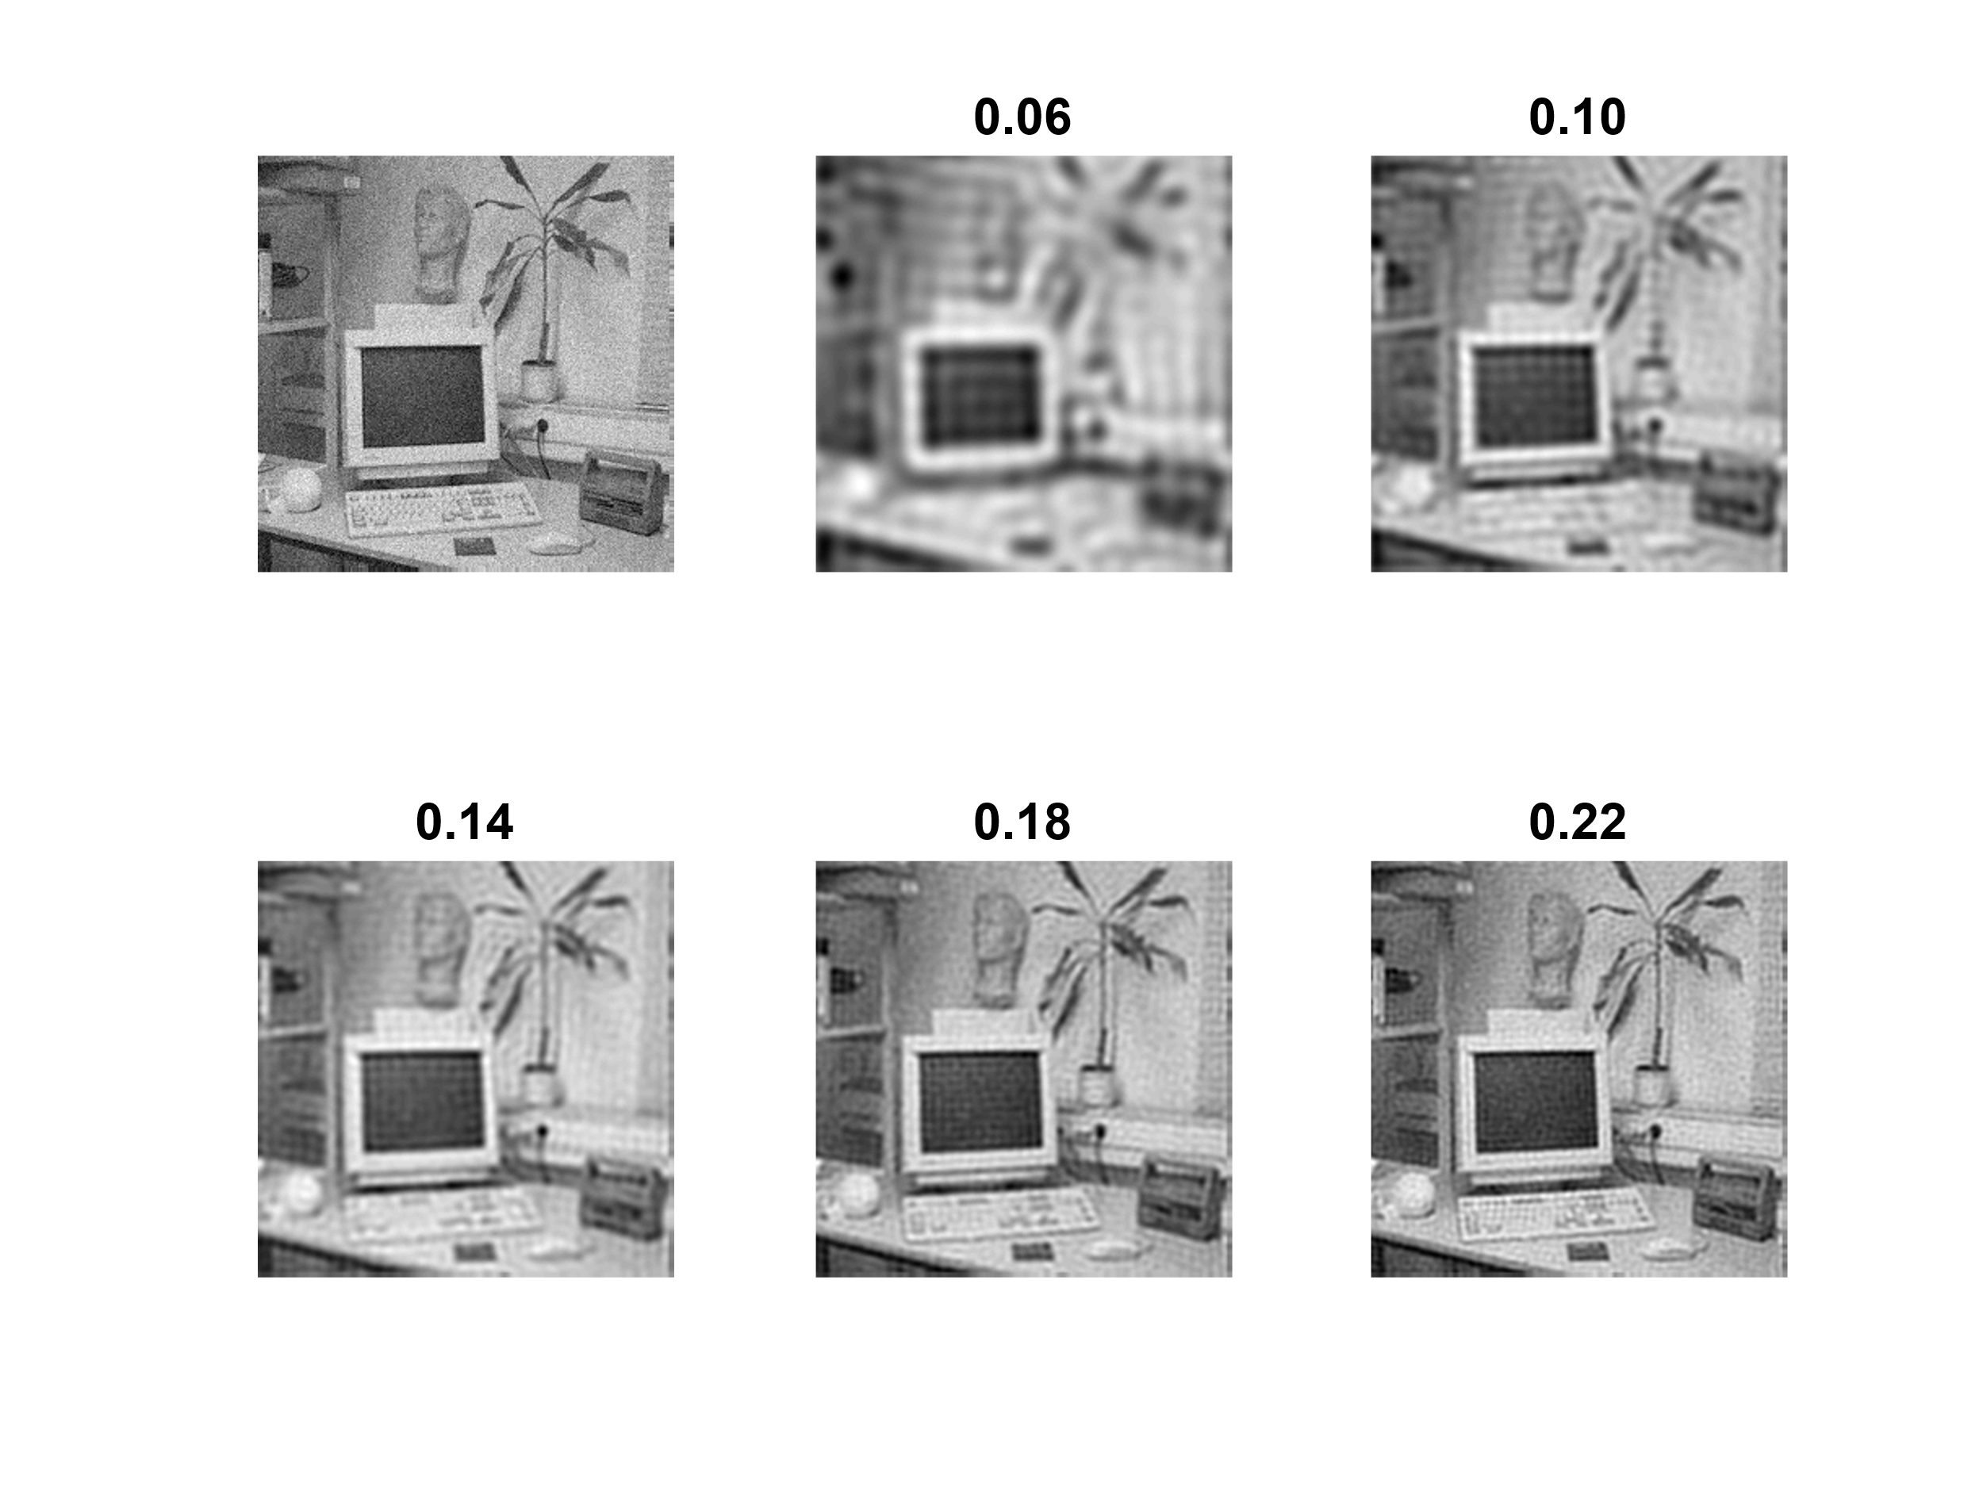

The gausian filter does reduce nois, however it also blurs the image and reduces details

The median filter does remove salt and pepper noise, however the image does also loose details. It also introduces weird artifacts were edges are located. (the image looks kind of like a painting)

The ideal low pass manly introduces new noise and doesn’t really improve any of the images.(will give you headage if you look at it)

The parameters for the median filter is the height and width of the filter kernel. The filter takes the median of the pixel it is operating at and the surrounding pixels. (when the pixels are sorted)

The parameters for the ideal filter is the crossover frequency. The filter causes a ringing effect. Gibbs phenomenon, high frequency represent the flat top of the square wave.

The parameter for gauss is the variance which will effects the weights used in the filter kerne

___________________________________________________________________________

**Question 18**: What conclusions can you draw from comparing the results of the respective methods?

Answers:

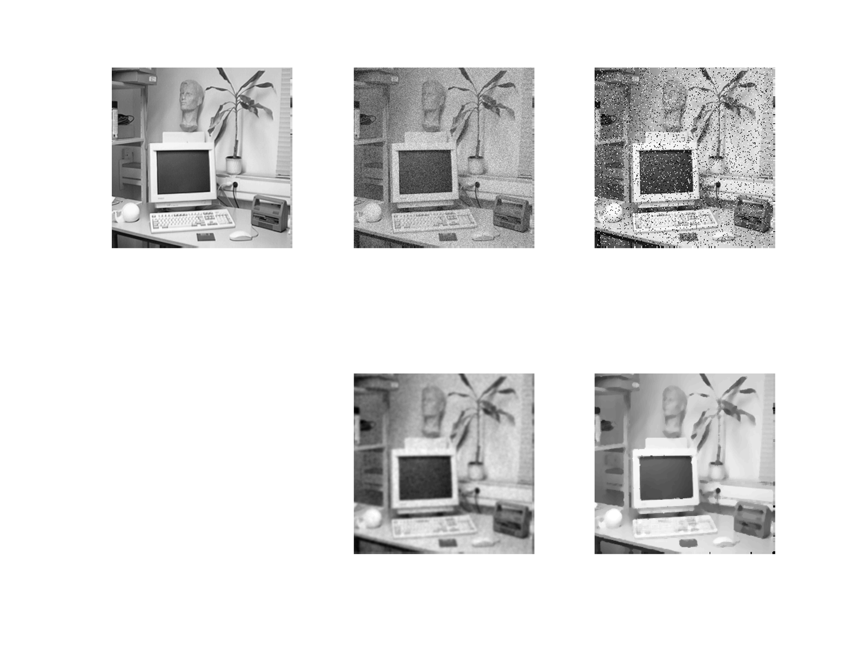

Median is suiatable for restoring images with salt and pepper noise.

Gauseian is suitable for restoring Images noisy images

Ideal low pass inst’t good for anything (useless)

___________________________________________________________________________

**Question 19**: What effects do you observe when subsampling the original image and the smoothed variants? Illustrate both filters with the best results found for iteration i = 4.

Answers:

We can see that the image that is filtered before it is subsampled looks better. The artifact with gaussian is that the image becomes blurrier, the artifact from ideal low pass is that we get some artifacts from the filter.

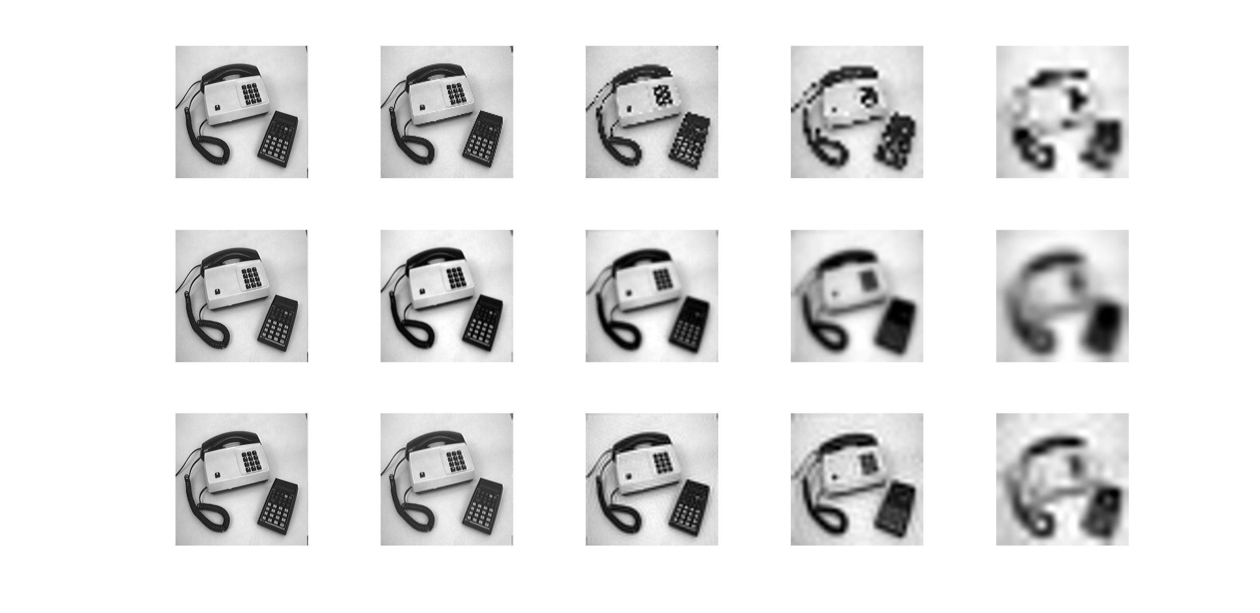

___________________________________________________________________________

**Question 20**: What conclusions can you draw regarding the effects of smoothing when combined with subsampling? Hint: think in terms of frequencies and side effects.

Answers:

When subsampling the image with a frequency under 2*the fmax Nyquist theorem, we can se that we get artifacts due to folding/aliasing. This is resolved by removing those frequencies first using a low pass

___________________________________________________________________________